

**H**

**A N D B O O K**

**2016-17**

**Central University of**

**Punjab**

**NACC ACCREDITED ’A’ GRADE UNIVERSITY**

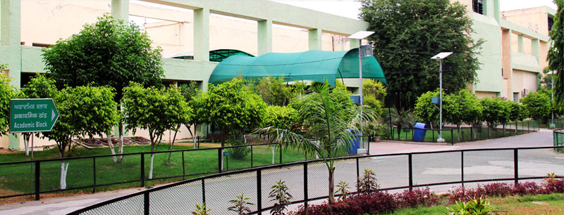

This Hand Book is designed to provide information about Central University of Punjab, Bathinda only. The publisher and author do not offer any legal or other professional advice through this handbook. Every effort has been made to make it as accurate as possible. However, there may be typographical and/ or content errors. Therefore, this Hand Book should serve only as a general guide and not as the ultimate source of information. This book contains information that intends only to make aware the students about who‟s who in the university and facilities provided to them.

|  |
| --- |
| **About CUPB……………………………………………………………4** |
| **From the desk of Hon’ble Vice Chancellor……………….6** |
| **Academic Calendar for Session 2016-17………………….7** |
| **Schools and Centres……………………………………………….9** |
| **Student Orientation……………………………………………..22** |
| **Student Mentoring……………………………………………….32** |
| **Computer Centre………………………………………………….33** |
| **Library………………………………………………………………….34** |
| **Research Infrastructure………………………………………..38** |
| **Clubs and Societies……………………………………………….41** |
| **Student Care and other facilities……………………………44** |
| **Student Financial Assistance…………………………………50** |
| **Placement Cell……………………………………………………..51** |
| **Anti-Ragging Cell………………………………………………….53** |
| **Grievance Redressal Cell……………………………………….53** |
| **Student Counselling Cell……………………………………….52** |
| **Anti-Discriminatory cell………………………………………..54** |
| **Competitive Examination Cell……………………………….54** |
| **Student Discipline…………………………………………………55** |
| **Student Code of Conduct………………………………………55** |
| **Feedback………………………………………………………………56** |
| **Alumni Association ………………………………………………56** |
| **Important CUPB numbers…………………………………….56** |
| **Know Bathinda…………………………………………………….57** |
| **List of Holidays………………………………………...............58** |

Table of Contents

About CUPB

The Central University of Punjab, Bathinda (Punjab) has been established through the Central Universities Act 2009 which received the assent of the President of India on 20th March 2009. Its territorial jurisdiction extends to the whole State of Punjab. This newly set up Central University of Punjab (CUPB) at Bathinda is poised to write new alphabet on the academic horizon of India. This University is one of the important links in the recently set up chain of Central Universities created in the educationally backward areas of India. Going to be an upwardly mobile

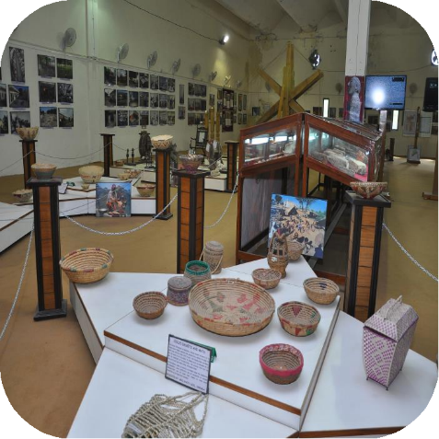

organization, it is destined to emerge as a quality provider of teaching and research, knowledge and skills, products and services, attitudes and ethics. It is gearing up to provide proper institutional leadership to the emerging demands of access, equity, relevance and quality in the mainstream University system. It has already flexed its muscles and initiated its first academic session. The University would dynamically and creatively respond to the shifting paradigms in education in tune with the changing needs of society. This holistic, inclusive and multi- disciplinary University provides an academically ambient environment to develop technologically superior individuals. The University aims to sponsor

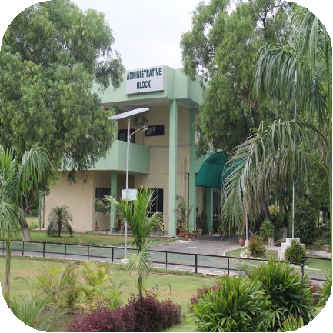

time-bound and goal-oriented research and development projects of various types for users like industries, companies and other agencies in India and abroad.

The Central University of Punjab is an ultra-modern and futuristic seat of higher learning and focusses on creating a community of teachers, scholars and researchers dedicatedly absorbed in academic exploration, research and development, testing and consultancy. It plans to have world class infrastructure which would be eco-friendly, and optimally used, with the potential to absorb even yet to emerge technologies. It is striving to be an autonomous and hassle-free space where the creative minds would converge and construct world class knowledge and vision, and where new ideas would germinate, strike roots and grow wings.

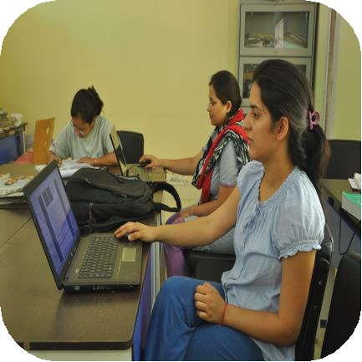

The University is creating supporting and stimulating conditions and opportunities whereby one can learn, grow, interact and discover. It is an exciting, safe, healthy, motivated and happening place with a green energy efficient, Wi-Fi campus, innovative and ignited faculty, global level laboratories, automated libraries, vast playgrounds, auditorium, research centres and other high class support systems. The University has introduced participatory delivery techniques facilitated through seminars, group discussions, off campus visits, online support, web, multimedia, live projects, field studies, demos, team presentations, skill workshops,

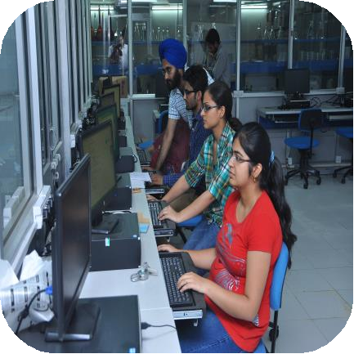

etc. The University celebrates diversity and open to all persons the world over, irrespective of nationality, class, colour, creed, caste, religion and gender. Human and technological concerns are the bottom-line of this

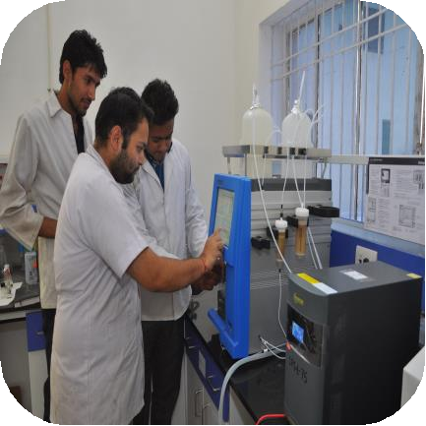

organization. It is endeavouring to develop human resource who would be morally upright, intellectually well-informed, socially concerned, physically well-developed, emotionally balanced and culturally bloomed. The University works with utmost ethics, transparency, non-interference, accountability and decentralization. This University is committed to fulfil all the criteria in terms of programmes, faculty, infrastructural supports, and other norms as laid down by the University Grants Commission, and the Ministry of Human Resource

Development, Government of India. It would carve out

and maintain its national character and global outreach through its instructional and research programmes. It is a multi-facility and multi- faculty university enshrining state-of-the-art infrastructural support systems for teaching and research. It brings into public domain the global technological trends for the benefit of every strata

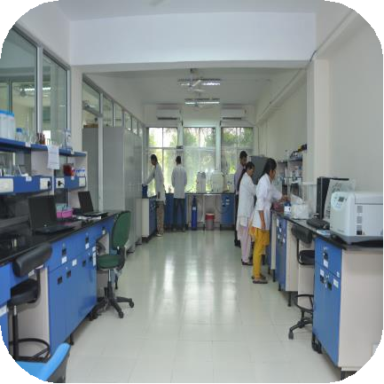

of society. It started its functioning from Camp Office in April, 2009, which happens to be the residence of the Vice Chancellor, and from November 2009 it shifted to its City Campus spread over an area of 35 acres. The main campus is coming up on 500 acres of land near Bathinda.

From the Desk of Vice Chancellor

*Dear Students*

*Welcome to the Central University of Punjab*

*I congratulate you for joining Central University of Punjab, one of the fast growing Central Government’s Educational Institutions committed to capacity building and offering outstanding academic, recreational, sporting, co-curricular and placement opportunities. Here, students enjoy a perfect balance between high educational standards and a lifestyle coupled with Indian ethos and modernity.*

*CUP is devoted to excellence in higher education and research, and producing the finest human beings with highest quality scientific minds engaged in eternal quest for infinite knowledge and solving problems of mankind.*

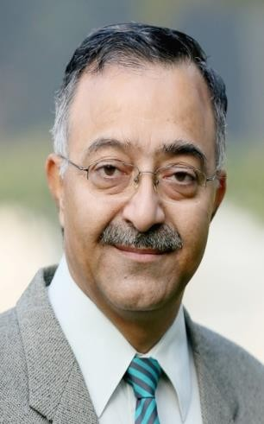

*We aim to build top quality intellectual capital by constantly motivating young minds to learn and enjoy the excitement & adventure that education offers; create a vibrant culture integrating world-class education and cutting edge research with a focus on higher learning for Indian and foreign youth; inculcate amongst students and faculty, healthy habits of self-reliance rather than dependence. We strive on holistic development of personality to face challenges of life while ensuring welfare of all life forms and life support systems; activate creative instincts, motivate independent thinking; develop questioning minds and to nurture a sense of integrity, ethics, uncompromising honesty, democratic values, respect for human rights and deep concern for the disadvantaged section of the society.*

*We at CUP understand that success is based on high quality courses, good facilities, friendly ambience and dedicated academic staff. Here, we practise what we teach and our students can count on full support of faculty and administration. Our strength lies in dedicated and meritorious faculty, very good infrastructural research facilities and visibilities in research output. Majority of the faculty has sponsored research project funding. Our M. Phil. and Ph.D. students enjoy scholarship support. The innovative courses are designed to save precious time, money and energy of the students while they remain focused to the field of their choice. In order to strike a balance between academic pursuits and leisure, the university offers clean and green surroundings together with good sporting and extracurricular facilities.*

*With Best Wishes*

R. K. Kohli

Vice Chancllor

i. Academic Calender for Session 2016-17

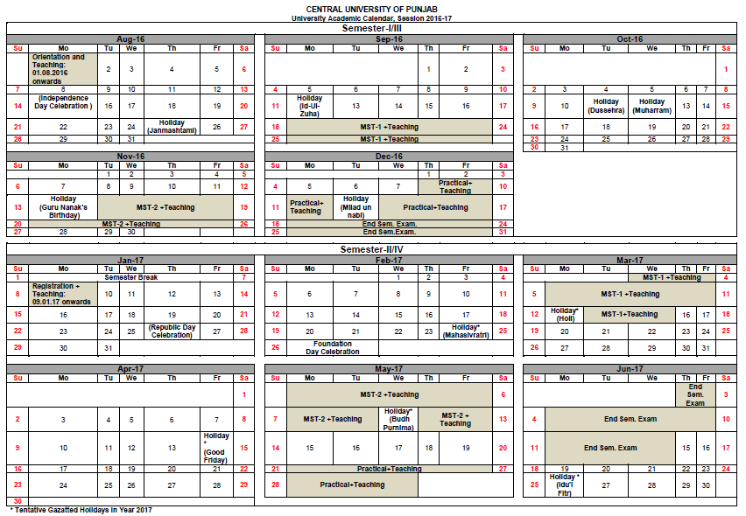

|  |  |  |  |
| --- | --- | --- | --- |
| ii. Summary of Teaching | | | |
| **Semester- I/III** | | **Semester- II/IV** | |
| **Month** | **Days** | **Month** | **Days** |
| Aug-16 | 21 | Jan-17 | 16 |
| Sep-16 | 21 | Feb-17 | 17 |
| Oct-16 | 19 | Mar-17 | 22 |
| Nov-16 | 21 | Apr-17 | 19 |
| Dec-16 | 11 | May-17 | 22 |
|  |  | Jun-17 | 0 |
| Total Days | 93 | Total Days | 96* |
| **\*96 days (including 2 days for the Sports meet)** | | |  | |

**Deadlines**

**Semester I/III**

1. Registration of 1st and 3rd semester students: 29th July 2016

2. Submission of interim report (3rd semester) M.Pharm. and M.Tech.: on or before16th December 2016

3. Pre-submission seminar of 3rd semester students: Between 5th December 2016 and 29th December 2016

4. Submission of Dissertation/thesis: 30th December 2016

**Semester II/IV**

1. Registration: 09th January 2017

2. Pre-submission seminar of 4th semester students: Between 15th May 2017 and 13th June 2017

3. Submission of Dissertation/thesis: 14th June 2017

iii. Schools and Centres

**1. School of Basic & Applied Sciences**

***i. Centre for Animal Sciences***

**Faculty of the Centre**

|  |  |  |
| --- | --- | --- |
| **Name** | **Qualification** | **Designation** |
| Prof. P. Ramarao | Ph.D., M.Pharm. | Dean |
| Dr. A. K. Mantha | Postdoctoral training, Ph.D.,  M.Phil., M.Sc., B.Sc. | Assistant Professor  and COC |
| Dr. Jyoti Parkash | Ph.D. | Assistant Professor |
| Dr. Ajay Kumar | Ph.D. | Assistant Professor |
| Dr.Krishna Chaitanya Rapalli | Ph.D. | Assistant Professor |

**Programmes offered by the Centre**

|  |  |
| --- | --- |
| **Programmes** | **Eligibility** |
| M.Sc. in Life Sciences with specialization in Animal Sciences | Bachelor‟s degree in any branch of Life Sciences with  55% marks from a recognized Indian or foreign university. |

***ii. Centre for Applied Agriculture***

**Faculty of the Centre**

|  |  |  |
| --- | --- | --- |
| **Name** | **Qualification** | **Designation** |
|  |  |  |
|  |  |  |
|  |  |  |
|  |  |  |

**Programmes offered by the Centre**

|  |  |
| --- | --- |
| **Programmes** | **Eligibility** |
| M.Tech (Food Science and Technology) | B.Tech. / B.E. Degree in Dairy Technology / Food Technology / Food Processing Technology / Food Engineering / Agri. Engineering / Chemical Engineering with minimum 55% of marks or its equivalent in aggregate. |
| MBA (Agri-Business) | B.Sc. Agriculture/Science/B.Com with 55% with Agriculture or Commerce as main Subject. |

***iii. Centre for Biochemistry and Microbial Sciences***

**Faculty of the Centre**

|  |  |  |
| --- | --- | --- |
| **Name** | **Qualification** | **Designation** |
| Prof. P. Ramarao | Ph.D., M.Pharm. | Dean |
| Prof. Ramakrishna  Wusrika | Ph.D. | Professor and  COC |
| Dr. Monisha Dhiman | Ph.D. | Associate Professor |
| Dr. Malkhey Verma |  | Associate Professor |
| Dr. Shashank Kumar | Ph.D. | Assistant Professor |
| Dr. Somesh Baranwal | Ph.D. | Assistant Professor |
| Dr. Pramod Kushawaha | Ph.D. | Assistant Professor |
| Dr. Manju Jain | Ph.D. | Assistant Professor |

**Programmes offered by the Centre**

|  |  |
| --- | --- |
| **Programmes** | **Eligibility** |
| M.Sc. in Life Sciences with  specialization in Biochemistry | Bachelor‟s degree in any branch of Life Sciences with 55% marks from a recognized Indian or foreign university |
| M.Sc. in Life Sciences with  specialization in Microbial Sciences |
| Ph.D. in Biochemistry and Microbial Sciences |  |

***iv. Centre for Chemical Sciences***

**Faculty of the Centre**

|  |  |  |
| --- | --- | --- |
| **Name** | **Qualification** | **Designation** |
| Prof. P. Ramarao | Ph.D., M.Pharm. | Dean |
| Dr. Rakesh Kumar | Ph.D. | Assistant Professor and  OIC |
| Dr. Krishna Kanta Haldar | Ph.D. | Assistant Professor |
| Dr. Rajendra Singh Dhayal | Ph.D. | Assistant Professor |
| Dr. J. Nagendra Babu | Ph.D., M. Sc. | Assistant Professor |

**Programmes offered by the Centre**

|  |  |
| --- | --- |
| **Programmes** | **Eligibility** |
| M.Sc. in Chemical Sciences  with specialization in Medicinal Chemistry/ Organic Chemistry/ Inorganic Chemistry / Physical Chemistry | Bachelor's degree in Science with  Chemistry as a subject with 55% marks in aggregate from a recognized Indian or foreign university. |
| Ph. D. in Chemical Sciences |  |

***v. Centre for Computational Sciences***

**Faculty of the Centre**

|  |  |  |
| --- | --- | --- |
| **Name** | **Qualification** | **Designation** |
| Prof. P. Ramarao | Ph.D., M.Pharm. | Dean |
| Dr. Kousik Giri | Ph.D., M.Sc., B.Sc. | Assistant Professor |
| Dr. Mahesh Kulharia | Post-doctoral fellow,  Ph.D., M. Sc., B. Sc. | Assistant Professor |

**Programmes offered by the Centre**

|  |  |
| --- | --- |
| **Programmes** | **Eligibility** |
| M.Sc. in  Computational  Sciences | Bachelor‟s degree in Chemical/ Physical/  Mathematical/ Biological Sciences/ B.Tech. or B.E. in Bioinformatics or Chemical Engineering/ B.Pharm. with a minimum of 55% marks from a recognized Indian or foreign University. |

***vi. Centre for Mathematics and Statistics***

**Faculty of the Centre**

|  |  |  |
| --- | --- | --- |
| **Name** | **Qualification** | **Designation** |
| Prof. P. Ramarao | Ph.D., M.Pharm. | Dean |
| Dr. Rajesh Gupta | Ph.D. | Associate Professor and COC |
| Dr. Gauree Shankar | Ph.D. | Associate Professor |
| Dr. Sachin Kumar | Ph.D. | Assistant Professor |
| Dr. Anoop Kumar | Ph.D. | Assistant Professor |
| Dr. Harmanpreet Singh Kapoor | Ph.D. | Assistant Professor |

**Programmes offered by the Centre**

|  |  |
| --- | --- |
| **Programmes** | **Eligibility** |
| M.Sc. in Mathematics | Bachelor‟s degree in science with Mathematics  as main subject with 55% marks in aggregate from a recognized Indian or foreign university. |
| M.Sc. in Statistics | Bachelor‟s degree in science with  Mathematics/Statistics as main subject with 55% marks in aggregate from a recognized Indian or foreign university |
| Ph. D. in Mathematics |  |
| Ph. D. in Statistics |  |

***vii. Centre for Pharmaceutical Sciences and Natural Products***

**Faculty of the Centre**

|  |  |  |
| --- | --- | --- |
| **Name** | **Qualification** | **Designation** |
| Prof. P. Ramarao | Ph.D., M.Pharm. | Professor and Dean |
| Dr. Raj Kumar | B. Pharmacy, M.S. (Pharm.) (Medicinal Chemistry), Ph.D. (Medicinal Chemistry) | Associate Professor and COC |
| Dr. Vinod Kumar | Ph.D., B.Ed., M.Sc., B.Sc. | Assistant Professor |
| Dr. Vikas Jaitak | Ph.D., B. Ed, M.Sc., B.Sc. | Assistant Professor |
| Dr. Pradeep Kumar | Ph.D.,M. Pharm., B. Pharm. | Assistant Professor |

**Programmes offered by the Centre**

|  |  |
| --- | --- |
| **Programmes** | **Eligibility** |
| M.Pharm. in Pharmaceutical  Sciences (Medicinal Chemistry) | Bachelor‟s degree in Pharmacy  with 55% marks from a recognized Indian or foreign university and also having valid GPAT score. |
| M.Pharm. in Pharmaceutical  Sciences (Pharmacognosy and  Phytochemistry) |
| M.Sc. in Chemical Sciences(Medicinal Chemistry | Bachelor's degree in Science with Chemistry as a subject with 55% marks in aggregate from recognized Indian or foreign university. |
| Ph. D. in Medicinal Chemistry |  |

***viii. Centre for Physical Sciences***

**Faculty of the Centre**

|  |  |  |
| --- | --- | --- |
| **Name** | **Qualification** | **Designation** |
| Prof. P. Ramarao | Ph.D., M.Pharm. | Dean |
| Dr. Rupesh S. Devan | Ph.D. | Associate Professor and COC |
| Dr. Achchhe Lal  Sharma | Ph.D., M.Sc., B.Sc. | Assistant |
| Prof. A.P. Pathak | Ph.D. | Visiting Professor |
| Dr. Kamlesh Yadav | Ph.D., M.Sc., B.Sc. | Assistant Professor |
| Dr. Ashok Kumar | Ph.D. | Assistant Professor |

**Programmes offered by the Centre**

|  |  |
| --- | --- |
| **Programmes** | **Eligibility** |
| M.Sc. in Physics | Bachelor‟s degree in science with Physics and Mathematics as main subjects with 55 % marks in aggregate from a recognized Indian or foreign university |
| Ph.D. in Physics |  |

***ix. Centre for Plant Sciences***

**Faculty of the Centre**

|  |  |  |
| --- | --- | --- |
| **Name** | **Qualification** | **Designation** |
| Prof. A. K. Dhawan | Ph.D. | Invited Professor and  COC |
| Dr. Felix Bast | B.Sc., M.Sc., Ph.D. | Assistant Professor |
| Dr. Sanjeev Kumar | Ph.D., M.Sc., B.Sc. | Assistant Professor |
| Dr. Pankaj Bhardwaj | Ph.D., M.Sc., B.Sc. | Assistant Professor |
| Dr. Vinay Kumar | Ph.D. | Assistant Professor |

**Programmes offered by the Centre**

|  |  |
| --- | --- |
| **Programmes** | **Eligibility** |
| M.Sc. in Life Sciences  with specialization in  Plant Sciences | Bachelor‟s degree in any branch of Life Sciences  with 55% marks from a recognized Indian or foreign university. |
| Ph.D. in Life Sciences |  |

**2. School of Education**

***i. Centre for Education***

**Faculty of the Centre**

|  |  |  |
| --- | --- | --- |
| **Name** | **Qualification** | **Designation** |
| Prof. S. K. Bawa | Ph.D. | Professor, Dean and  COC |
| Dr. Sesadeba Pany | Ph.D. | Assistant Professor |
| Dr. Shamshir Singh  Dhillon | M.Sc. M.Ed. PhD.  (Edu).UGC-NET (Edu.) | Assistant Professor |
| Dr. Jubilee Padmanabhan | Ph.D., M.Ed., M.Sc. | Assistant Professor |

**Programmes offered by the Centre**

|  |  |
| --- | --- |
| **Programmes** | **Eligibility** |
| M.Ed. in Education | Candidates seeking admission to M.Ed.  programme must have passed B.Ed. B.A.Ed./B.Sc.Ed./M.Sc. B.Ed / or any other degree recognised as equivalent thereto by the University with 50% marks in the theory papers (in case of integrated degree course,  50% aggregate marks in Education papers only). |
| M.A. in Education | Bachelor‟s degree in any stream with 50%  marks from a recognized Indian or foreign university. |
| Ph. D. in Education |  |

**4. School of Engineering & Technology**

***i. Centre for Computer Science & Technology***

**Faculty of the Centre**

|  |  |  |
| --- | --- | --- |
| **Name** | **Qualification** | **Designation** |
| Prof. A. K. Jain | Ph.D., M.E., B.E. | Dean |
| Dr. Amandeep Kaur | Ph.D., M.E., B.E. | Associate Professor and COC |
| Er. Meenakshi | M.E., B.Tech. | Assistant Professor |
| Er. S. S. Khurana | M.E., B.Tech. | Assistant Professor |
| Dr. Satwinder Singh | Ph.D. | Assistant Professor |

**Programmes offered by the Centre**

|  |  |
| --- | --- |
| **Programmes** | **Eligibility** |
| M.Tech. in Computer Science and Technology | B.Tech. / B.E. in Computer Science and  Engineering / Information Technology / Electronics  / Electronics & Communication from a recognized Indian or foreign university with minimum 55% marks. Preference will be given to candidates having valid GATE score. |
| M.Tech. in Cyber  Security |

**5. School of Environment & Earth Sciences**

***i. Centre for Environmental Sciences & Technology***

**Faculty of the Centre**

|  |  |  |
| --- | --- | --- |
| **Name** | **Qualification** | **Designation** |
| Dr. Vinod Kumar Garg | Ph.D. | COC |
| Dr. Sunil Mittal | Ph.D., M.Sc., B.Sc. | Assistant Professor |
| Dr. Yogalakshmi K. N. | Ph.D., M.Sc., B.Sc. | Assistant Professor |
| Dr. Dhanya M.S. | Ph.D., M.Sc., B.Sc. | Assistant Professor |
| Dr. Puneeta Pandey | Ph.D., M.Phil., M.Sc., B.Sc. | Assistant Professor |

**Programmes offered by the Centre**

|  |  |
| --- | --- |
| **Programmes** | **Eligibility** |
| MSc in Environmental Sciences and Technology | Bachelor's degree or equivalent in any branch of biological/chemical/environmental sciences or an engineering degree with minimum 55% marks from a recognized Indian or foreign university |
| Ph.D. in Environment Science and Technology |  |
| Integrated M.Phil., Ph.D. in EVST |  |

***ii. Centre for Geography and Geology***

**Faculty of the Centre**

|  |  |  |
| --- | --- | --- |
| **Name** | **Qualification** | **Designation** |
| Dr. Vinod Kumar Garg | Ph.D. | Dean |
| Dr. Kiran K. Singh | Ph.D. | Assistant Professor and OIC |
| Dr. Jitendra Pattanaik | Ph.D. | Assistant Professor |
| Dr. L.T. Sasang Guite | Ph.D. | Assistant Professor |
| Dr. K. Milankumar Sharma | Ph.D. | Assistant Professor |

**Programmes offered by the Centre**

|  |  |
| --- | --- |
| **Programmes** | **Eligibility** |
| M.A. in Geography | Bachelor's degree in arts with Geography as main subject with 55% marks in aggregate from a recognized Indian or foreign university. |
| M.Sc. in Geography | Bachelor's degree in science with Geography as main subject with 55% marks in aggregate from a recognized Indian or foreign university |
| M.Sc. Geology | Hons. in Geology at B.Sc. level/Bachelor's degree with Geology as main subject with 55% marks in the aggregate in Science subjects. |
| Ph.D. Geology |  |
| Ph.D. Geography |  |

**6. School of Global Relations**

***i. Centre for Economic Studies***

**Faculty of the Centre**

|  |  |  |
| --- | --- | --- |
| **Name** | **Qualification** | **Designation** |
| Prof. S. K. Bawa | Ph.D. | Dean |
| Dr. Pabitra Kumar  Mishra | Ph.D. | Associate Professor and  COC |
| Dr. Sandeep Kaur | Ph.D., M.Sc. | Assistant Professor |
| Dr. Naresh K. Singla | Ph.D., M.Sc., B.Sc. | Assistant Professor |
| Dr. Jainendra Kumar  Verma | Ph.D. | Assistant Professor |

**Programmes offered by the Centre**

|  |  |
| --- | --- |
| **Programmes** | **Eligibility** |
| M.Phil. in Economics | Master‟s Degree in Economics or allied / relevant  field with 55% marks from a recognized Indian or foreign university |
| M.A. in Economics | Bachelor‟s degree with Economics as a subject  of study or its equivalent in any discipline with  55% marks in aggregate from a recognized  Indian or foreign university. |

***ii. Centre for Sociology***

**Faculty of the Centre**

|  |  |  |
| --- | --- | --- |
| **Name** | **Qualification** | **Designation** |
| Prof. S. K. Bawa | Ph.D. | Professor and Dean |
| Dr. Vinod Arya | Ph.D. | Assistant Professor |
| Dr. Aditya Ranjan Kapoor | Ph.D. | Assistant Professor |
| Dr. Sumedha Dutta | Ph.D. | Assistant Professor |

**Programmes offered by the Centre**

|  |  |
| --- | --- |
| **Programmes** | **Eligibility** |
| M.A. Sociology | Bachelor's degree with Sociology as main subject  with 55% marks in aggregate from a recognized  Indian or foreign university |

***iii. Centre for South and Central Asian Studies***

**Faculty of the Centre**

|  |  |  |
| --- | --- | --- |
| **Name** | **Qualification** | **Designation** |
| Prof. S. K. Bawa | Ph.D. | Professor and Dean |
| Dr. Vinay Kumar Rao | Ph.D. | Associate Professor and COC |
| Dr. Bawa Singh | Ph.D., M.A. | Assistant Professor and |
| Dr. Nishtha Kaushiki | Ph.D., M.Phil., M.A., B.A. | Assistant Professor |
| Dr. Sudheer Singh Verma | Ph.D. | Assistant Professsor |

**Programmes offered by the Centre**

|  |  |
| --- | --- |
| **Programmes** | **Eligibility** |
| M.Phil. in South and Central Asian Studies | Master's Degree in South and Central Asian Studies,  Indian History, Political Science, Economics, Sociology, Public Administration, Geography or allied/ relevant field with 55% marks from a recognized Indian or foreign university. |
| M.A. in Political  Science | Bachelor's degree with Political Science/International  Studies/International Relations as main subject with  55% marks in aggregate from a recognized Indian or foreign university |
| M.A. in History | Bachelor's degree with History as main subject with  55% marks in aggregate from a recognized Indian or foreign university |
| M.A. in Philosophy | Bachelor's degree with Philosophy as main subject  with 55% marks in aggregate from a recognized  Indian or foreign university |
| Ph. D. in South and Central Asian Studies |  |

**Clean and Green Campus**

**7. School of Health Sciences**

***i. Centre for Human Genetics***

**Faculty of the Centre**

|  |  |  |
| --- | --- | --- |
| **Name** | **Qualification** | **Designation** |
| Prof. A. K.  Dhawan | Ph.D. | Dean |
| Dr. Anjana Munshi | Ph.D., M.Phil., M.Sc. | Associate Professor and COC |
| Dr. Preeti Khetarpal | Ph.D., M.Sc. | Assistant Professor |
| Dr. Sandeep Singh | Ph.D. | Assistant Professor |
| Dr. Harish  Chander | Ph.D. | Assistant Professor |
| Dr. Sabyasachi Senapati | Ph.D. | Assistant Professor |
| Dr. Neeraj Kumar | Ph.D. | Assistant Professor |

**Programmes offered by the Centre**

|  |  |
| --- | --- |
| **Programmes** | **Eligibility** |
| PG Diploma in Translational Biomedical Research | Master’s degree in life sciences or Chemistry / B.Pharm. / MBBS / BDS / B.V.Sc. with 55% marks in aggregate from a recognized Indian or foreign university. |
| Ph.D. in Human Genetics |  |
| Ph.D. in Molecular Medicine |  |
| M.Sc. in Life Sciences with Specialization Human Genetics | Bachelor’s degree in any branch of life sciences/M.B.B.S. or B.D.S. with 55% marks from a recognized Indian or foreign university.   |  | | --- | |  | |
| M.Sc. in Life Sciences with Specialization Molecular Genetics | Bachelor's degree in any branch of animal/medical sciences/life Sciences or any other related science  with 55% marks from a recognized Indian or  foreign university.  . |
| M.Sc. in Human Genetics |  |

**8. School of Language, Literature & Culture**

***i. Centre for Comparative Literature***

**Faculty of the Centre**

|  |  |  |
| --- | --- | --- |
| **Name** | **Qualification** | **Designation** |
| Prof. S. K. Bawa | Ph.D. | Dean |
| Dr. Zameerpal Kaur | Ph.D., Tripple M.A.,  PGDCA | Associate Professor and  COC |
| Dr. Amandeep Singh | Ph.D., M.A. | Assistant Professor |
| Dr. Rajinder Kumar | Ph.D. | Assistant Professor |

**Programmes offered by the Centre**

|  |  |
| --- | --- |
| **Programmes** | **Eligibility** |
| M.Phil. in  Comparative  Literature | Master's Degree in Comparative Literature /  Linguistics / any Indian Language or allied / relevant field with 55% marks from a recognized Indian or foreign university. |
| M.A. in English | Bachelor’s degree with English as a subject of study with 55% marks in aggregate from a recognized Indian or foreign university. |
| M.Phil., Ph.D. Integrated Programme in Comparative Literature |  |

***ii. Centre for Classical and Modern Languages***

**Faculty of the Centre**

|  |  |  |
| --- | --- | --- |
| **Name** | **Qualification** | **Designation** |
| Prof. S.K. Bawa | Ph.D. | Dean |
| Dr. Alpna Saini | Ph.D., M.A. | Associate Professor  and COC |
| Dr. Ramanpreet Kaur | Ph.D., M.Phil.,  Double M.A., B.A. | Assistant Professor |
| Dr. Dinesh Babu P. | Ph.D. | Assistant Professor |
| Dr. Shahila Zafar | Ph.D. | Assistant Professor |

**Programmes offered by the Centre**

|  |  |
| --- | --- |
| **Programmes** | **Eligibility** |
| M.A. in English | Bachelor’s degree with English as a subject of study with 55% marks in aggregate from a recognized Indian or foreign university. |
| M.A. in Punjabi | Bachelor’s degree in any stream with 50% marks from a recognized Indian or foreign university. |
| Ph.D. in English | Master's Degree in English or allied / relevant field with 55% marks from a recognized Indian or foreign university. |
| Ph.D. In Punjabi | Master's Degree in Punjabi or allied / relevant field with 55% marks from a recognized Indian or foreign university. |

**9. School of Legal Studies & Governance**

***i. Centre for Law***

**Faculty of the Centre**

|  |  |  |
| --- | --- | --- |
| **Name** | **Qualification** | **Designation** |
| Prof. P. Ramarao | Ph.D., M.Pharm. | Dean |
| Dr. Tarun Arora | Ph.D., LL.M., LL.B.,  B.Com. | Associate Professor and  COC |
| Dr. Deepak Kumar | LL.D., LL.M., LL.B.,  B.Sc. | Assistant Professor |
| Dr. Puneet Pathak | D.Phil., LL.M., LL.B.,  B.A. | Assistant Professor |
| Dr. Sukhwinder  Kaur | Ph.D. | Assistant Professor |
| Dr. Surendra Mehra | Ph.D. |  |

**Programmes offered by the Centre**

|  |  |
| --- | --- |
| **Programmes** | **Eligibility** |
| LL.M. with specialization in  Environment Law / Human  Rights Law / Corporate Law | Bachelor‟s Degree in Law with 55%  marks from a recognized Indian or foreign university. |
| Ph.D. in Law |  |

**Women security guards at girls’ hostel**

iv.Student Orientation

The orientation program is meant to orient the students to the campus life. The program facilitates the successful academic and personal transition of new students to the CUPB community.

**Features**

* It gives an overview of university culture, resources and services along with rules and regulations.
* It is held at the beginning of the session

**Objectives**

* To welcome the student to the university and engage them with the legacy, traditions and values of our university
* To introduce students to the rigorous academic life of the university and opportunities, responsibilities and facilities available
* To explain rules and regulations to CUPB especially related to teaching learning and examination

v. Academic Admission Rules

Teaching and learning is a continuous process in which teacher and student develops a bond. Teachers keep getting new students year after year and with the passage of time gain rich experience. In order to improve her/his competence in teaching and/ or research she/he needs the feedback from the students. The students can provide their feedback at the end of every semester for each course by hiding their identity. The feedback form is to be filled online, the data of which is kept confidential and is used only for improvement purposes

Rules and Regulations for Master’s Degree Programme (except M.Phil) (Applicable w.e.f. academic session 2015-16 ) {Sub – section (1) (b) of Section 28 of the Central Universities Act, 2009}

1. TITLE AND COMMENCEMENT

1.1 These rules and regulations shall be called the Rules and Regulations of Master’s Degree Programme herein after referred to as the Programme, and shall be applicable to all the Masters Degree programmes unless otherwise stated.

1.2 Subject to the overall control of the Academic Council, the programme shall be administered by the concerned School/Centre.

1.3 These rules and regulations shall be called the Rules and Regulations of Master’s Degree Programme herein after referred to as the Programme, and shall be applicable to all the Masters Degree programmes unless otherwise stated

2. DURATION

2.1 Unless otherwise provided in the statutes governing Master’s Degree Programme, the minimum duration for completion of each Master’s Degree Programme shall be 04 semesters (2 academic years) and the maximum duration shall be 6 semesters (3 academic years).

2.2 In respect of candidates who had discontinued for a valid reason (with the permission of competent authority) and are readmitted to the programme by the School, the period for which such candidates had discontinued shall not be counted while calculating the maximum period of is 06 semesters (3 years) prescribed in clause 2.1

2.3 A semester (s) may be declared a zero semester (s) in case of a student who could not continue with the programme during that period due to illness and hospitalization or due to accepting a foreign scholarship/fellowship or any other valid reason accepted by the Vice Chancellor subject to the fulfilment of requirements as laid down by the relevant rules. Such zero semester (s) shall not be counted for calculation of the duration of the programme in case of such a student.

3. NUMBER OF SEATS

The number of seats in each Master’s programme, shall be as approved by the statutory bodies of the university.

4. ADMISSION CRITERIA

4.1 Admission of a candidate to the programme would be made only in its first semester. He/she shall be promoted to the subsequent semesters of the programme after completing necessary formalities as specified under clause 8.

4.2 In exceptional cases lateral entry of a candidate, shall be considered for admission to a later semester of any programme following the prescribed procedure.

4.3 International students may be admitted to this programme according to the policy guidelines laid down by the university.

4.4 No candidate shall be eligible for admission to the programme if he/she is already registered for any other full time programme of this university or any other university/Institute. Note: However, students admitted to evening Post Graduate Diploma Programmes shall be permitted to pursue any regular programme in other institutions. Students admitted to a regular programme in the university shall also be permitted to pursue part-time evening Certificate/Diploma Programmes of professional nature in the university or other institutions, provided that permission has been obtained from competent authority of the university.

4.5 No candidate admitted to this programme shall undertake any employment or join any other course of study before completing the minimum residency period as may be decided by the university.

5. ELIGIBILITY FOR ADMISSION

5.1 A candidate shall be eligible for admission to the programme in any discipline provided he/she fulfils the minimum eligibility conditions as notified by the university.

5.2 For SC/ST and persons with disabilities (PWD) candidates, relaxation in minimum eligibility shall be given as per policy of the Government of India and the guidelines of the UGC.

5.3 The policy of the Government of India and the guidelines of the UGC, regarding reservation of seats for candidates belonging to Scheduled Castes, Scheduled Tribes, OBCs and for persons with disabilities (PWD) candidates shall be implemented.

6. PROCEDURE FOR ADMISSION

6.1 As per Academic Calendar, the University shall invite applications from eligible candidates for admission to the programme in each academic session, giving details of the academic calendar, number of seats available, eligibility criteria, prescribed fees, etc.

6.2 Admission for the programme shall be advertised in leading newspapers at the national level and also on the university website.

6.3 The admission to the programme shall be made on the basis of the entrance test to be conducted by the university as per a schedule to be notified for the purpose and/or score in qualifying degree/examination or as decided by the statutory bodies of the university. The entrance test shall be conducted at national level at the designated centres to be decided by the university, depending upon the number of students opting for a centre.

6.4 The selected candidates shall submit the prescribed fee and other relevant documents to the university within the stipulated time.

7. PROGRAMME STRUCTURE

7.1 University shall follow a Choice Based Credit System (CBCS) in all its Masters Programmes. The programme shall consist of at least 90 credits (except M.Tech.,M.Ed.,LL.M and M.Pharm.) covering theory and practical courses, a compulsory seminar and dissertation research/industrial project in the relevant discipline.

7.2 The credit requirement for professional Programmes M.Tech. and M.Pharm. shall be determined as per requirements of respective National Regulatory bodies for these programmes.

7.3 Subject to the approval of Academic Council, the syllabus for the courses and the methodology and instructional designs to be used shall be prepared/prescribed and published by the respective School Boards.

7.4 Courses in a programme may be of three kinds: Core, Elective and Foundation as per the CUPB policy in CBCS.

7.5 A candidate may be required to take additional non-credit courses on the recommendation of Supervisor, Coordinator of Centre and Dean of the concerned School. The marks for such courses shall not be counted towards CGPA.

7.6 The evaluation of dissertation shall be done as per Clause 16 and no marks shall be awarded.

7.7 Subject to the approval of the Academic Council, the syllabus for the courses and the methodology and instructional designs to be used shall be prepared, prescribed and published by the respective School Boards.

7.8 The topic of the dissertation shall be approved by the School/Centre on a proposal submitted by the student through his/her supervisor.

7.9 The topic of dissertation, once decided shall ordinarily remain unchanged during the whole programme. However, the Dean of the concerned School on the recommendations of Centre Coordinator and supervisor of the student may permit a modification in the topic, if considered necessary. Major changes can be made in the topic only after the approval of the Vice Chancellor.

7.10 A student who does a part of his/her dissertation work at any centre other than the centre concerned (External Centre) shall be required to submit a progress report on the work carried out by him/her as well as a certificate regarding regular attendance at the External Centre duly approved by the external supervisor(s) as well as by the internal supervisor(s).

8. REGISTRATION AND PROMOTION TO THE NEXT SEMESTER

8.1 Every student admitted to the programme shall get registered at the beginning of the 1st semester of the programme in the Centre/School by completing the necessary formalities as per the schedule announced by the university.

8.2 A student shall be promoted and permitted to get registered in the next semester provided he/she:

8.2.1 Fulfils the prescribed requirements of continuous internal assessment/project work/practical work as required under the regulations.

8.2.2 Passes at least 50% of courses in the semester concerned.

8.2.3 Puts in required attendance in each course/semester as provided under clause 9

8.3 A student found not eligible to appear in the End-Semester Examination of a course of the programme due to shortage of attendance or those who fail in more than 50% of the prescribed courses in any semester shall be required to repeat the courses and take readmission in respective semester of the programme in the following academic year.

8.4 A student shall not be permitted to register in a subsequent semester of a programme unless he/she has been a registered student of the immediate preceding semester and has pursued the course (s) of that semester as a regular student.

8.5 In each semester, a last date shall be fixed and notified in the beginning of the semester after which admissions/re-admissions/promotion/registration shall not be ordinarily made.

8.6. Under special circumstances, the students may be allowed late registration by a specified date, by paying a late fee fixed for the purpose, along with the other prescribed fees.

9. ATTENDANCE

9.1 A candidate to be eligible for Continuous Internal Assessment/End Semester Examination of a course or a complete semester shall have to put in a minimum of 75% attendance in that course/semester in addition to satisfying all other relevant conditions laid down in the regulations.

9.2 The Dean of School, on recommendation of the Centre Coordinator concerned, may condone the shortage of attendance to a maximum of 5% if the claim is justified and supported by valid documents and on payment of fine as approved by competent authority.

9.3 The Dean Academic Affairs, on recommendation of the Centre Coordinator and Dean of the School may condone shortage of attendance beyond 5% but only up to a maximum of 10% for valid reasons (to be supported by documentary evidence) and on payment of fine as approved by the competent authority.

9.4 The teacher concerned shall be responsible for maintaining the record of attendance of the students registered for the course.

10. SUSPENSION/WITHDRAWAL.

A student suspended or debarred from attending the classes due to any reason, whatsoever, or having withdrawn from a semester (s) on medical grounds or for any other cogent reason, shall have to seek re-admission in the appropriate semester in the next academic session as a regular student. Such students shall have to meet the prescribed requirement of attendance in each course in the semester.

11. FEES TO BE PAID.

The amount and mode of payment of fees payable at the time of admission, registration during subsequent semesters, at the time of examination and refund of fee under special circumstances will be governed by the relevant Rules and Regulations of the university in this regard.

12.MEDIUM OF INSTRUCTION AND EXAMINATION

12.1 The language for the instruction and examination shall be English.

12.2 In cases the programme pertains to any language other than English, the instructions and examinations would be in that language.

13. EXAMIATION AND EVALUATION

13.1 A student shall be continuously evaluated for academic performance in a course through a surprise test (s), pre-announced tests, tutorials, practical work, assignment (s), term paper, field work, seminar (s), periodical tests and the End-Semester Examination, as prescribed in the examination scheme of the respective course and duly approved by the authority concerned.

13.2 Following evaluation procedure shall be applicable: 1. Surprise Test(s): One or more such tests with multiple choice questions 2. Continuous Assessment: Continuous Assessment will be based on two preannounced Tests having both short answer subjective type and one Long answer type subjective question, term papers, assignments, practical etc. 3. End Term Examination: Having multiple choice questions

13.3 All the examinations shall be conducted by the teacher(s) concerned under the overall supervision of the Centre Coordinator and Dean of the School. The Coordinator of the Centre shall report the award list in respect of all courses taken by different students to the Controller of Examinations through the Dean of the School within seven days of the completion of examination.

13.4 In case a student could not appear in any component of the Continuous assessment of a course due to medical reasons or under other exceptional circumstances (supported by documentary evidence), a separate examination in that component may be arranged by the concerned Centre Coordinator before the beginning of End Semester Examination.

13.5 The End Semester Practical Examination (wherever applicable) shall ordinarily be held before the theory examinations.

13.6 A student shall be permitted to appear in the End-Semester Examination as per the Conduct of Examination Rules after filling up the prescribed examination form, payment of the prescribed examination fee, satisfying the attendance requirement and fulfilling other eligibility criteria.

13.7 The question paper pattern of End Semester Examination shall be prescribed by the School concerned, and it will be compulsory to pass this examination for successful completion of the course.

13.8 Unless prescribed in the Regulations and the Scheme of Examination of a particular programme, a candidate shall be deemed to have completed his/her courses successfully if he/she obtains minimum Grade point of 4 as per the following 10 point system in each course.

13.9 If a student passes in at least 50% of prescribed courses of a semester he/she shall be allowed to repeat the End Semester Examination of the remaining course(s) along with regular students of preceding semester without putting in any additional attendance. The marks for all other components as applicable shall however, be carried forward in such cases. The students shall be required to deposit the examination-form along with prescribed fee

13.10 A student failing in more than 50% of the courses in a semester shall have to seek readmission in the appropriate semester as a regular student.

13.11 The marks obtained in the Continuous Internal Assessment (CIA) shall be shown to the students.

14. AWARD OF MARKS SHEET

14.1 On successful completion of each semester examination, the student shall be awarded grades/grade points for that semester indicating simultaneously the CGPA/SGPA in the previous semester(s).

14.2 The Marks-Sheet of last semester shall indicate the grades obtained and credits earned for each course, and Cumulative Grade Point Average (CGPA) as prescribed in the Regulations duly approved by statutory bodies of the university. Letter Grade point O Outstanding 10 A+ Excellent 9 A Very good 8 B+ Good 7 B Above Average 6 C Average 5 P Pass 4 F Fail 0 Ab Absent 0

15. IMPROVEMENT OF GRADE

15.1 Students who have been declared pass in a course (s) shall be allowed to repeat any component of continuous assessment and End Semester Examination in order to improve his/her grade/CGPA/division along with regular students in corresponding semesters, provided that CGPA of such a student is less than 6.0 on 10 point scale. No separate examination would be arranged for such students. There would be no limit for numbers of chances to improve.

15.2 Such students shall have to apply for improvement of grade/marks/division and pay the fees prescribed from time to time.

15.3 If the candidate improves grade/marks, then the improved grade/marks shall be taken into account for working out revised award and a revised marks sheet shall be issued to him/her on the surrender of the marks sheet issued earlier. Such improved marks will not be counted for the award of Prizes/Medals, Rank and Distinction. If the candidate does not show improvement in the grade/marks, his/her previous grade/marks will continue to be taken into account.

15.4 No candidate shall be allowed to improve grade/CGPA in the practical, project work and seminar and field work.

16. EVALUATION OF DISSERTATION

16.1 Prior to submission of the dissertation student shall make a pre-submission presentation in the Centre that shall be open to all faculty members and research students, for getting feedback and comments, which shall be suitably incorporated into the draft dissertation under the advice of his/her supervisor.

16.2 Every candidate shall submit with his/her dissertation a certificate from the supervisor (s) that the dissertation submitted is a record of original research work carried out by the candidate under his/her supervision and that the dissertation has not previously formed the basis for the award of any degree/diploma, or other similar titles of this or any other university and that the dissertation represents independent work of the candidate.

16.3 A panel of not less than six having present or past affiliation with a reputed university or an accredited institution of higher learning, shall be submitted by the supervisor of the student to the Vice Chancellor for approval through the Coordinator of Centre and the Dean of concerned School for evaluating the dissertation and conducting the viva-voce examination to be held later. The Vice Chancellor may appoint an examiner other than those proposed by supervisor of the candidate(s) also. The Controller of Examinations shall contact each of the approved examiners to seek their consent and arrange the evaluation of dissertations and conduct of viva-voce examination of the students.

16.4 The external examiner (s) shall not be connected with the university, and shall be known for having made rich contributions to knowledge in their respective area (s) of study.

16.5 Each examiner, after examining the dissertation submitted by the candidate for the award of degree, shall submit a detailed report on a prescribed format along with a clear recommendation whether, in his/her opinion: (a) The dissertation should be accepted for the award of degree and the public defense and viva-voce examination of the candidate should be held. OR (b) The dissertation should be referred back to the candidate for revision OR (c) The dissertation should be rejected.

16.6 If the dissertation is approved, the examiner (s) may seek clarification questions, if any, to be answered by the candidate at the time of public defense and viva-voce.

16.7 In case the examiner does not approve the dissertation of a candidate, it would be referred to another examiner from the panel previously submitted or as approved by the Vice Chancellor. If the second examiner also does not approve the dissertation, then students will be required to resubmit the dissertation.

16.8 If the examiner (s) explicitly suggest revision and re-submission of dissertation for further examination, then the revised dissertation duly certified by the Supervisor, Centre Coordinator and the concerned Dean shall be sent to the same examiner for further evaluation unless he/she is unable or unwilling to act as such, in which case different examiner (s) may be appointed. If the examiner concerned specifically instructs that the revised thesis need not be sent back to him/her, the revised thesis duly certified by the Supervisor, Centre Coordinator and the concerned Dean shall be accepted and the candidate shall be allowed for public defense and viva-voce.

17. CONDUCT OF VIVA-VOCE

17.1 After the dissertation is approved by the external examiner, a panel comprising the supervisor, the Coordinator of the concerned Centre and the Dean concerned or his nominee shall conduct viva-voce examination of the candidate in the presence of interested faculty members and students.

17.2 A candidate, who is not successful in the viva-voce examination, shall undergo the viva-voce examination second time, within a period of four months. In the event he/she fails again, the Dean shall refer the matter to the concerned School Board for decision.

17.3 If the performance of a candidate in viva-voce examination is satisfactory, the Coordinator of concerned Centre, through the Dean concerned shall forward the recommendations of the examiner (s) who adjudicated the dissertation/ thesis and the evaluation of the candidate’s performance in viva-voce examination along with other such documents as may be required, by the university to Controller of Examinations for consideration and approval by the Vice Chancellor.

18. AWARD OF DEGREE

18.1 The successful candidates shall be admitted to and conferred the Degree in the respective discipline, as the case may be, provided he/she has:

18.1.1 No pending dues to the university, hostel or library outstanding

18.1.2 No disciplinary action pending against him/her

18.1.3 Fulfilled such other conditions as prescribed under rules

18.2 For those candidates who have qualified for the degree in disciplines which are interdisciplinary in nature, the university may issue the degree in the respective discipline in which they have registered and have completed their programme.

19. POWER TO REMOVE ANY DIFFICULTY

Notwithstanding what is contained in the Regulations; the Chairperson, Academic Council/Executive Council may in exceptional circumstances and on the recommendations of the School Board concerned or an appropriate Committee on the merits of each individual case consider, and for reasons to be recorded, allow relaxation of any of the provisions except those prescribing CGPA requirement.

vi. Ph.D. programmes for those candidates who have qualified UGC-CSIR

Norms for Admission in Ph.D. programmes for those candidates who have qualified UGC-CSIR NET with valid JRF or any other JRF through national level examination and external funding.

As per recommendations of Ph.D. Admission Committee and subsequent approval of competent authority the admission in Ph.D. programmes for those candidates who have qualified UGC-CSIR NET with valid JRF or any other JRF through national level examination and external funding will be done by following manner: Admissions shall be done any time of the year provided that:

* Admission will be done subject to availability of faculty, infrastructure for research and the specializations.
* The candidate will submit the application directly to the concerned COC. After ascertaining eligibility, availability of faculty, infrastructure for research and the specializations, the COC will recommend and forward the case to the Vice chancellor through Dean of school and DAA for approval of admission.
* The Date of Registration will be the date of submission of fee by the candidate after due approval of his/her admission by the competent authority.
* The course work will be started in the beginning of a semester (August or January) as notified by the centre/Controller of Examination later.
* The COC/OIC will be responsible for offering the course work in the even as well as odd semester if the admissions is made after the last date of stipulated admission dates of an academic session.

vii. Examination System

Sub: Pattern of Examination System w.e.f. Academic Session 2015-16.

* Surprise Test(s): There will be three surprise tests, out of three, the average of best two will be considered. Surprise test will be of multiple choice questions and total weightage of surprise tests will be 25%
* Mid Semester Tests: Continuous Assessment will be based on two pre-announced Tests. These tests will be subjective type and will contain short answer type questions and one Long answer type question.
* Each MST will carry 25% weightage and total weightage of MSTs will be of 50%.
* End Semester Examination: End semester examination will be conducted online in university computer centre. End Semester examination will be based on MCQs/fill-ups. Weightage of end semester examination will be of 25%

viii. Student Mentoring

The Mentoring agenda at CUPB is exclusive that works on the principle of assisting and empowering the Mentee. Friend-Philosopher-Guide, we embark on this approach. Each faculty is appointed mentor for a group of students. A mentor helps each student to realize and develop his or her potential and efficiently express personal thoughts about the system.

The mentor helps the students to become aware about their academic strengths and limitations. We focus on the areas of developing academic skills that strengthen their career plans. The counselling sessions are to be held once in a week and students are recommended to attend all the sessions as it facilitates a positive change in the pursuit of their goal.

Facilities at CUPB

ix. Computer Centre

The university has a modern computer centre with around 160 units of parallel- connected latest configuration workstations (Dell®)/HP each featuring Windows 7 ultimate OS, 2 GB/4 GB RAM and Intel®

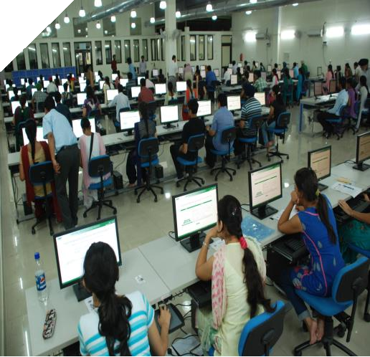

i5/i7 3 GHz processors. Software solutions such as GeneMapper®, SeqScape®, BioTrekker™, SigmaPlot® with Systat, PAWS, SPSS, Chem. Bio, Origin 8.1, Schrodinger, MATLAB, etc. have been procured. The University has also installed a Blade Server with capacity for 16 blades. The present number of populated blades is twelve, each with 16 GB RAM. The

university has excellent internet facility. Two Lease lines(20 MBPS and 100 MBPS and 1 GBPS NKN Link have already been installed

**Computer Centre is opened from 8:30 AM to 6.30 PM from Monday to**

**Friday and 9 AM to 5.30 PM on Saturday.**

**Important rules while accessing Computer Centre:**

1. Locker facility is available in the entrance to keep belongings before accessing the systems.

2. Mobile phones have to be in airplane/silent mode. Answering phone calls inside the lab is strictly prohibited.

3. Eating/drinking inside the centre is strictly prohibited.

4. Students need to log in the system by using username and password allotted to them. You may contact Mr. Yadvinder Singh/Mr. Mandeep Singh, Junior Technical Assistant for log-in credentials.

5. Accessing social network sites (Facebook, Google+, Orkut etc.) are strictly prohibited.

6. Accessing pornography websites are strictly prohibited and it will lead to legal actions.

**7.** Portable USB storage media (Pen Drives) and Optical Media (CD/DVD/BlueRay etc) are blocked in all the systems except system 1L1 to 8L1 and 1R1 to 8R1. To save files in these systems, a map-drive facility is available, so as shared USB hubs.

For details, contact

*Mr. Amandeep Singh Mann/ Ms. Usha Sharma.*

x. Library

The University Library is on a rapid and consistent path of expansion and development since its inception in 2009, catering to the learning and research requirements of teachers and students of the university. Carefully designed with elegant modular furniture, the library presently has over 27,170 titles and subscribes to 40 international and national print journals, the University Library subscribes to a large number of electronic journals through the UGC-INFONET Digital Library Consortium and independently apart from subscribing to 8900 full text online journals through the UGC-

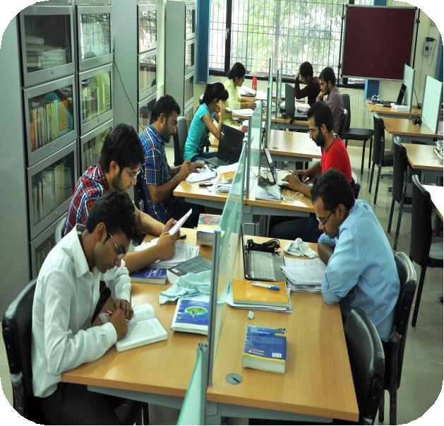

INFONET Digital Library Consortium and independently, with access to American Chemical Society, American Physical Society, Annual Reviews, Cambridge University Press, IEEE / IEE Electronic Library Online (IEL), Institute of Physics, JSTOR, Oxford University Press, Project Muse, Royal Society of Chemistry, Sage, Science Direct, Science Online, , Springer Link, Taylor & Francis, Wiley-Blackwell etc. The University Library has access to all important full text data base including CMI, Prowess, States of India, Indiastat.com, DELNET Online, ISID (The Institute

for Studies in Industrial Development), JCCC (J-Gate Custom Content for Consortium), Hein Online, Manuparta, SciFinder Evaluation, SCOPUS, Web of Sciences etc. It is fully air- conditioned and is located at a central place in the Academic Block with state-of-the-art seating facility, apart from a quiet and restoring ambience. The interior of the library is enabled with Wi-Fi connectivity allowing the users to work within the library by accessing both offline and online resources. This University Library is equipped with Radio Frequency Identification (RFID) and Electro Magnetic Security System (EMSS)

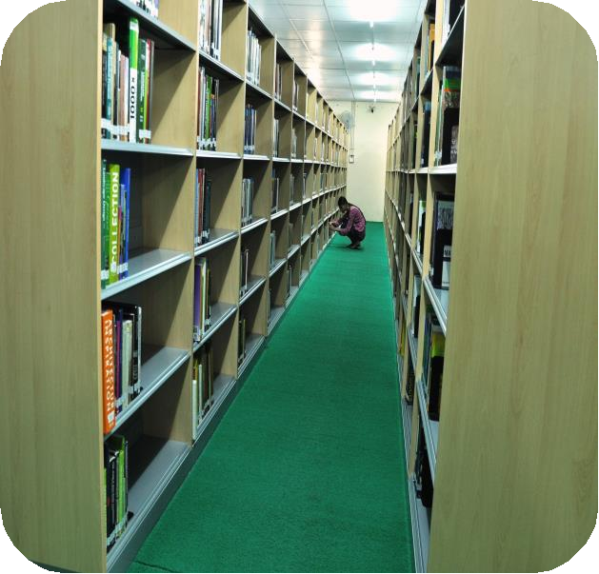

providing automated self-service facility for the users and high end security. It is also equipped with an advanced Online Public Access Catalog (OPAC) and modern reprographic facilities.

**Library Sections**

* General Book Section
* Text Book Section
* Reference Book Section
* Regional Language Section
* Donated Book Section
* Braille Section
* Thesis and Dissertations’ Section
* Audio-Video Section
* Newspaper Corner
* Maps and Atlas Section

**Library Collections**

The library collection consists of Books, Reference Books, Text Books, Print Journals, Newspapers, M.Phil Dissertations, E-Journals and Databases, CD ROM/DVDs.

|  |  |  |
| --- | --- | --- |
| **Sr. No.** | **Resources** | **Total** |
| 01 | Books | 27,500 |
| 02 | Journals in Print Format | 40 |
| 03 | E-Journals | 9107 |
| 04 | Thesis and Dissertation | 267 |
| 05 | News Papers | 21 |
| 06 | CD-ROM/DVD | 443 |

**Library Services**

* Reprographic services: University Library provides reprographic services to the users for photocopying library materials
* Reference Service: It provides the users with directional assistance in locating books and resources.
* Inter-library Loan (ILL): Assistance to access materials and resources from the networking libraries through DELNET.
* Current Awareness Service (CAS): Updating the users with the latest information in the academic front and new arrivals to the library.
* Selective Dissemination of Information (SDI): Provides information and updates to the interested users on specific theme/area/topic as required.
* Binding: Provides binding service to the users for official purposes.

**E-Journals**

|  |  |  |
| --- | --- | --- |
| **Publisher** | **URL** | **No of Title** |
| [American Chemical Society](http://pubs.acs.org/) | <http://pubs.acs.org/> | 37 |
| American Physical Society | <http://publish.aps.org/browse.html> | 10 |
| [Annual Reviews](http://arjournals.annualreviews.org/) | <http://www.annualreviews.org/> | 33 |
| [Cambridge University Press](http://journals.cambridge.org/) | <http://journals.cambridge.org/> | 224 |
| [Economic and Political Weekly](http://epw.in/) | <http://www.epw.in/> | 1 |
| [Institute of Physics](http://www.iop.org/EJ) | <http://iopscience.iop.org/journals> | 46 |
| [JSTOR](http://www.jstor.org/) | <http://www.jstor.org/> | 2585 |
| [Oxford University Press](http://www.oxfordjournals.org/) | <http://www.oxfordjournals.org/> | 206 |
| [Nature](http://www.nature.com/nature/index.html) | <http://www.nature.com/nature/index.html> | 01 |
| [Project Muse](http://muse.jhu.edu/journals) | <http://muse.jhu.edu/browse/> | 493 |
| Royal Society of Chemistry | <http://www.rsc.org/> | 29 |
| [Science Direct (10 Subject Collection)](http://www.sciencedirect.com/) | <http://www.sciencedirect.com/> | 1389 |
| [Springer Link](http://www.springerlink.com/) | <http://link.springer.com/> | 1763 |
| [Taylor and Francis](http://www.tandfonline.com/) | <http://www.tandfonline.com/> | 1173 |
| [Wiley-Blackwell](http://onlinelibrary.wiley.com/) | <http://onlinelibrary.wiley.com/> | 908 |
| Science Online | <http://www.sciencemag.org/> | 01 |

**E-Resources**

|  |  |
| --- | --- |
| **Publisher** | **Description** |
| Prowess  [http://prowess.cme.com](http://prowess.cme.com/) | Provides database of the financial performance and business of over 27,000 companies in India. |
| States of India  [http://statesofindia.cmie.com](http://statesofindia.cmie.com/) | Provides statistics, official documents of state governments in India on diverse fields and sectors. |
| Indiastat.com  [www.indiastat.com](http://www.indiastat.com/) | Provides ready to use data on socio-economic life of India and its states online. |
| DELNET Online  <http://delnet.nic.in/> | Promotes resource sharing among the libraries through the development of a network of libraries. Enables accessing data from the libraries in the network. |
| [ISID (The Institute for Studies in Industrial Development)http://isid.org.in/](http://isid.org.in/) | Access to databases on various aspects of the Indian economy, particularly industry and the corporate sector and On-line Indexes of Indian Social Science Journals (OLI). |
| JCCC (J-Gate Custom Content for Consortium) [http://jccc-indest.informindia.co.in /](http://jgateplus.com/search/) | JCCC provides a one point access to journals subscribed under UGC INFONET Digital library consortium as well as university libraries designated as Inter Library Loan (ILL) Centers. |
| Hein Online  [http://home.heinonline.org](http://home.heinonline.org/) | Provides access to more than 1,800 law and law-related periodicals. |
| Manuparta  [http://www.manupatra.com](http://www.manupatra.com/) | Provides databases on Legal, Taxation, Corporate and Business Policy. |
| SciFinder Evaluation[https://scifinder.cas.org/scifinder](https://scifinder.cas.org/scifinder/login) | Scientific database that focuses on chemistry. |
| Westlaw India  [http://www.westlawindia.com](http://login.westlawindia.com/maf/wlin/ext/app/tocectory?stnew=true&sttype=stdtemplate&sp=incupip-1) | Provide access to a large collection of case laws and legal materials from India, and outside particularly from the UK, EU, United States and other Commonwealth Jurisdictions. |
| SCOPUS  <http://www.scopus.com/> | Scopus, the largest abstract and citation database of peer-reviewed literature. |
| Web of Science  [https://webofknowledge.com](https://webofknowledge.com/) | Web of Science is an online subscription-based scientific citation indexing service maintained by Thomson Reuters that provides a comprehensive citation search. |

**Library Rules**

The students, teachers and staff of the university are entitled for membership in the University Library. University library published a library manual that deals with the important functions of   University Library and delineates policies about its activities such as collection, development, provision of information services and management of other academic support facilities. It is expected to bring clarity and uniformity in procedures and practices of the library and improve its efficiency, utility and services. The Manual link is given below:-  
[http://www.cup.ac.in/university_publications.php](http://cup.ac.in/publications/Library%20Manual%20A.pdf)

**Braille Section**

The University Library is also in a process of developing a separate Braille section for the visually handicapped users. The acquisition of books in Braille script has already started with quite a few numbers of books from history, literature, religion, etc. making their way into the stacks.

**Working Hours**

All working day = Round the Clock (24 Hours)  
All Saturdays, Sundays and Gazetted holidays =9.00 am to 5.30 pm

Feedback, suggestions and comments are welcome at [library.cup@cup.ac.in](mailto:library.cup@cup.ac.in) Ph. +91 164-2864140

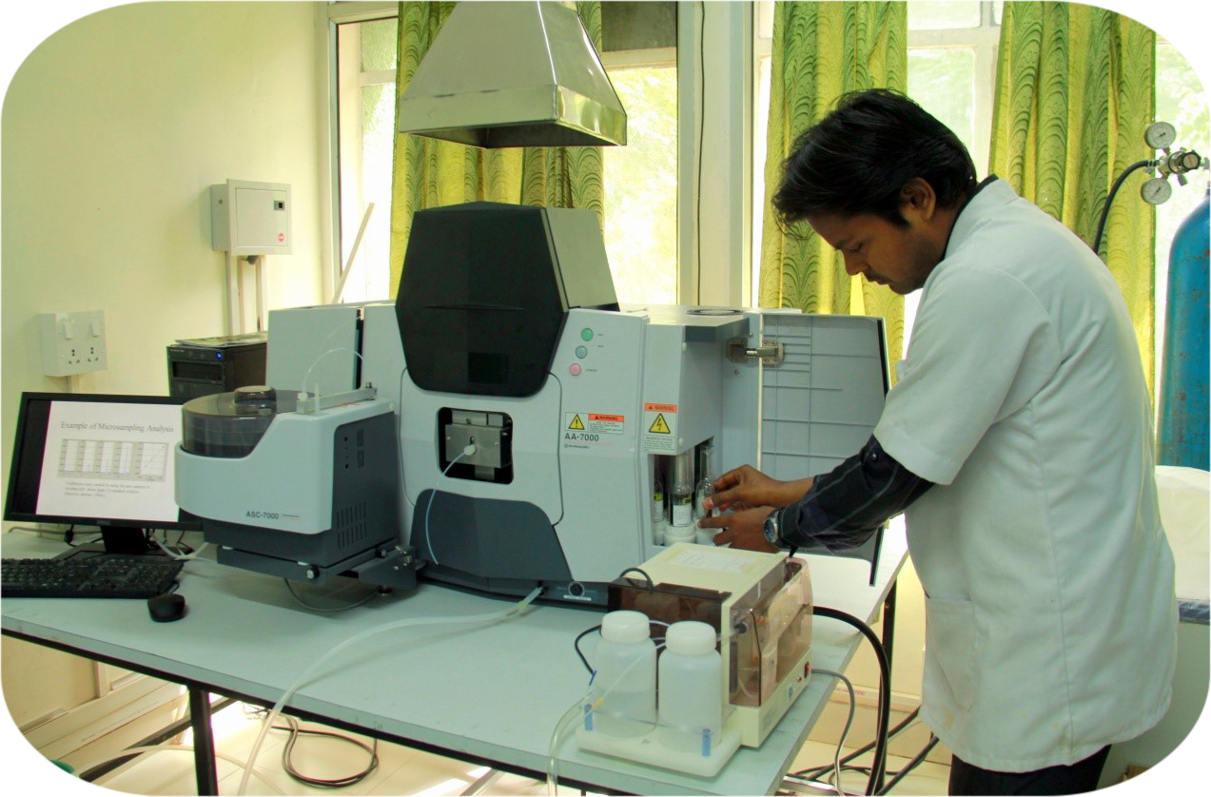

xi. Highlights of Research Infrastructure

Well-equipped tissue culture laboratories for plant, animal, human and cell-lines culturing and a Molecular Genetics laboratory having 96 capillary 3730XL high throughput DNA sequencer, RT PCR, Gradient PCR, UV-Visual Spectrophotometer, automated karyotyping system, Electrophoresis units, Gel documentation system, high precision water baths, Ultra-low temperature deep freezers, high speed cooling centrifuges, Vacuum Concentrator, NanoDrop 3000, CO2 incubators, and Millipore water purification systems have been established at the City Campus, to supplement the existing state of the art Biosciences, Chemical Sciences and Pharmaceutical Sciences laboratories.

Walk in cold room facility with three different temperature regimes available for short and medium term storage of biological materials for periods up to ten years.

A growth house and a screen house for multiplication and conservation of endangered plant species.

Atomic Absorption Spectrophotometer, Gas Chromatographic Mass Spectrometer,Fourier Transform Infrared Spectrometer and Microvoltameterhave been added to the central instrumentation facility.

Field-Emission Scanning Electron microscope, Confocal Laser Scanning Microscope with Fluorescence Correlation Spectroscopy and other sophisticated equipment being addedas central facility.

xii. Central Instrumentation Laboratory:

An Advanced Central Research Facility

In 2010, Central University of Punjab took an initiative towards development of a better, reliable and standard research platform, and established a common portal for basic and advanced science based research which was named as Central Instrumentation Laboratory. This laboratory was dedicated to cater the best of instrumental aspects of multidisciplinary research. It also aimed to provide the best and trained instrument professionals to the scientific community of the world.  
In its early days the laboratory would focus on the optimum usage of the equipments and instruments for the basic and technological research of the university.

xiii. Role of CIL in the University:

Central Instrumentation Laboratory (CIL) has been incepted in the University in 2010. An amount of Rs. 7 crores has been spent to house 8 state-of-the art instruments of common use type. It has been playing a pivotal role in supporting the research activities of the six Schools in Science and Technology and Twelve Centres distributed among these schools.

xiv. Facilities in the Laboratory:

The central instrumentation laboratory presently hosts the following analytical instruments

* DNA Sequencer
* Flow Cytometer
* Inductively coupled Plasma Mass spectrometer
* Gas Chromatography and Mass Spectrometer
* Atomic Absorption Spectrometer
* Ultra High Performance Liquid Chromatography
* UV-Visible Spectrometer
* Fourier Transform Infrared Spectrometer
* Gas Chromatography for Producer/ Biogas analysis

Apart from analytical instruments, laboratory also hosts an imaging section for basic and applied research in biological and material. The imaging instruments include

* Fluorescence Microscope
* Field Emission Scanning Electron Microscope(FESEM)
* Confocal Laser Scanning Microscope (CLSM)

xv. Research support:

The university has a high proportion of research students in the sciences and an active faculty of 25 in the science disciplines. The CIL is playing a vital role in meeting their equipment needs and this aspect is particularly appreciated by the newly joined faculties, who necessarily have to spend a few years initially in developing their research laboratories. CIL has been providing a major support to all the science schools with an average number of around 10 common-use type of state-of-the-art instruments covering microscopy, spectroscopy, and chromatography.

Within this small span of four years of its inception, the CIL has achieved an average of 7022 samples run every year with a highest amount of 10,880 samples taken up and completed in year 2014. With the increase in demand due to the growing faculty strengths of science schools the year 2014 has accounted for 10,880 samples studied publications.

* **Residence Engineer:** Mr. Ashish Pandey and Mr. Sumit Srivastava

Clubs and Societies

xvi. Students’ Film Club

Visual art such as films, documentaries, paintings, photographs are the most influential media to highlight the sociocultural issues of the society. These require special focus in finding growing talents of this field. The Central University of Punjab Visual Arts Society has been started with this view. The society screens films, documentaries related to social and environmental awareness. The club intends to expand knowledge in the field of cinematography and associated science and to impart cultural value as well obligation towards the society in which they live. There are around 350 CDs/DVDs in the university library. The films are shown on the following themes:

Food related issues, Explore your world, Water, climate, tsunami, sustainable energy, wild life, climate, health issues, climate change, sanitation and environment, Global warming, nature, energy and environment, Forests and environment, Agriculture and environment, Pesticides and environment, Pollution and environment, Health and environment, Sustainable development, Hands on films, Hindi films, General films on educational background etc. These films are shown to the students every Saturday in the auditorium of university from 4:00 p.m. to 6:00 (depends on movie). The students, who want to be members of this club may contact: **Dr. Sunil Mittal**

xvii. Innovators Club

As per the directions of the Honourable President of India, Sh. Pranab Mukherji, Central University of Punjab, Bathinda has taken an initiative to institute an Innovators Club. The one day celebration was the first activity in a series of events to be organised by the newly formed Innovators Club to recognise the unacknowledged innovations which could provide solutions to the emerging requirements and needs of the society in day to day activities. The first Innovators Day was organised on 17th January 2014.

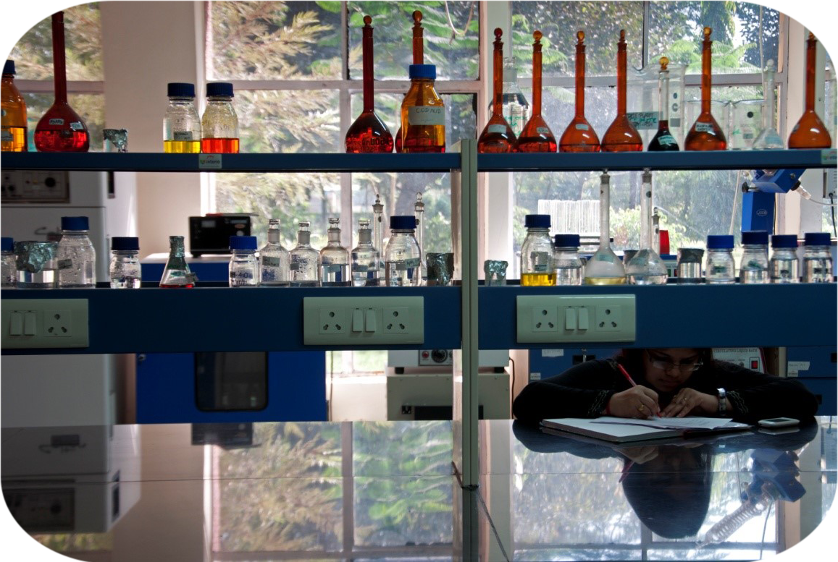

To encourage creativity and promote innovations among the students and general public, Central University of Punjab organised “Second Innovators Day” on Thursday, 22nd January, 2015. The key highlight of the program was to showcase their statistics/dynamic models/technologies in the exhibition cum competition. The event is open to all sections of society, Students, employees of public and private sector and general public. The main idea behind this club to provide a stage to all those innovators who want to share their unique innovations/ideas which fail to get recognition due to lack of proper documentation related with these inventions.

xviii. Students Environment Club

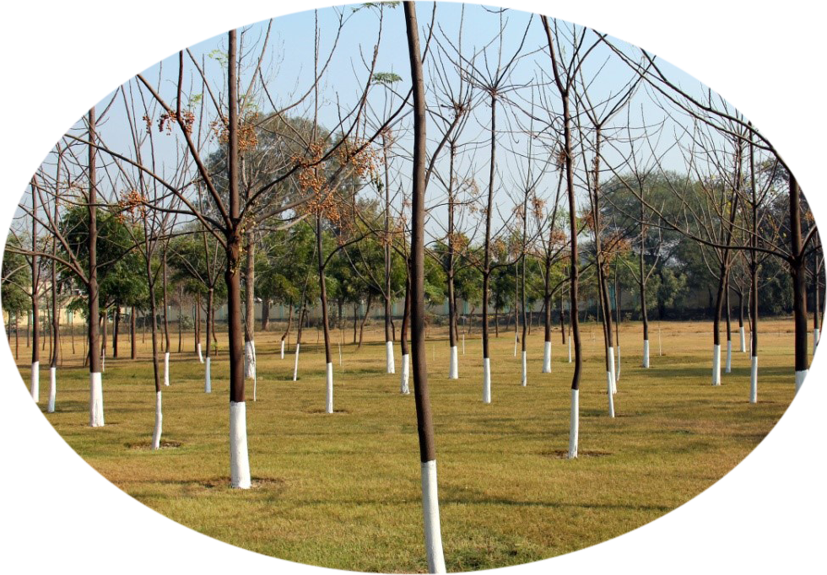

An Environment Club of Central University of Punjab, Bathinda was constituted for strengthening the activities related to various environmental issues, the environment awareness club and constitute other sub groups are reconstituted as below:

**It has different sub-groups as under:**

➢ **Waste and e-Waste Management Group**

The Central University of Punjab is a fast growing educational institution and the rapid increase in the students and staff community has led to huge amount of waste generation. The biodegradable and non-biodegradable wastes are generated in the university. The environmental and health impacts related with various types of wastes are a major concern. The management of waste is a necessity in the campus to make it green and to maintain the quality of the environment. This group creates awareness and educates the campus on the need of waste and e-waste management and makes the campus a zero waste zone and recycles and reuse the waste materials for value added environment friendly products.

➢ **Green campus group**

Due to unsustainable use of conventional sources of energy i.e. coal and petroleum, the carbon dioxide content of the atmosphere is increasing at the rate of more than 2 ppm annually. The current carbon-dioxide content in the atmosphere is about 395 ppm compared to about 300 ppm a hundred years ago. It is due to greenhouse effect causing gas and responsible for the climatic changes such as rising atmospheric temperature, causing rise in sea level, melting of glaciers, untimely and unpredictable precipitation etc. Trees are the natural carbon-dioxide absorbers which fixe the atmospheric carbon-dioxide into carbohydrates and oxygen. Apart from controlling the carbon dioxide, the green plants have several other benefits relating to control the atmospheric pollution. The waste material could be used as a source of energy. The use of wood as a source of energy is carbon neutral and does not disturb the ecology. It is therefore necessary that the earth planet should have a reasonable green tree cover. The Green campus group has been established on the campus with the following mandate:

* To initiate a tree plantation drive on the city campus and main campus of the university.
* To create awareness among the students and the residents of this part of the country through lectures by experts in this field and to start a tree plantation drive outside the university.
* Plantation of different native, ornamental, flowering, fruiting and other species of the trees on the main campus of the Central University of Punjab.

➢ **Renewable Energy Group**

Electricity is the main source of energy consumption for various activities in the offices, classrooms, laboratories, libraries, computer centre, hostels etc. For each unit of electricity consumed about 1.25 units of electricity is needed to be produced in the power plant for production of 1.25 units of electricity about 1 Kg of coal is consumed in the power plant, which releases about 1 Kg of carbon dioxide into the atmosphere. Carbon dioxide is a greenhouse gas and its accumulation in the atmosphere is responsible for climatic change. It is therefore necessary that we reduce the use of such conventional resources of energy. It is possible with the use of renewable sources of energy and conservation of energy. This group promotes renewable energy sources installation on the campus and brings awareness among the students regarding the use of renewable energy sources.

**Ragging is strictly prohibited on the Campus**

Student Care and Other Facilities

xix. Student Hostel

Choosing a University is also about choosing a new home. We ensure that students dwell in a healthy environment that helps them to grow and learn without any obstacle. CUPB has separate hostels for boys and girls with all modern facilities. The hostel mess serves fresh and hygienic food.

The university has 3 girls’ hostels and 4 boys’ hostels having single and double-seater rooms. The facilities provided in the hostels are: free Wi-Fi, bed, mattresses, study table, chair, almirah, 24x7 water and electricity supply, housekeeping facility, hygienic food, separate reading room in every hostel, common room with TV facility.

Air-conditioned reading room facility for the students is available close to boys’ and girls’ hostels. This facility is open round the clock.

Hostel Rules

1. Accommodation in hostel is given on merit. Criteria for allotment of hostel are given in the Hostel Manual.

2. Use of addictive substances is strictly prohibited.

3. Possession of any lethal weapon/instrument is strictly prohibited.

4. No students’ meeting in hostel is allowed without written permission of the Dean Students Welfare.

5. Day scholars are not allowed to stay in hostel without permission of Dean Students Welfare.

6. Electric appliances cannot be used/installed in the rooms.

7. Meals will not be served / taken in hostel rooms and cooking in hostel room is not allowed.

8. Vehicles are not allowed in hostel compound.

9. No change of room is allowed without permission of Dean Students Welfare.

10. No guest / unauthorized person is allowed to stay in hostel room.

11. Prior permission is required before leaving the hostel during weekends/holidays.

12. Any celebration/party cannot be held in hostel without permission of Dean Students Welfare.

13. Permission from warden is required to stay out for academic work in labs/library after the scheduled time of the hostel.

14. Strict action will be taken by the authority for any kind of property damage.

15. Keeping of pets/animals is strictly prohibited.

16. Accommodation is allotted for one year. Every year new allotment procedure needs to be adopted.

17. Students will not be allowed to stay in the hostel for more than the stipulated period of the completion of their respective programmes without permission of the competent authority.

18. Stay during summer vacation is not allowed except with the permission of Dean Students Welfare and on payment of summer fees.

19. Full or part time employees will not be allotted hostel accommodation.

20. Any student found with tainted background or against whom proof of indiscipline is found, will not be given admission in the hostel.

21. If a student drops her/his studies or leaves the centre before completion of the programme, he/she will have to vacate the hostel as well.

22. Any student found ragging in the hostel will be severely dealt with.

23. If a student is found absent in daily attendance, action will be taken by hostel administration.

24. Students will themselves take care of cleanliness of their rooms.

25. Warden can search the rooms of students any time.

26. Students may be asked to vacate the hostels in case of emergency situations.

27. Students are advised not to keep valuables in hostels, in case of loss, occupants themselves will be responsible.

28. The timing of hostel will be changed twice a year, i.e. during summer and in winter.

29. The overall control of hostels will vest with Dean Students Welfare.

* Prof. A.K. Dhawan, Dean Students Welfare
* Dr. Tarun Arora, Chief Warden Boys
* Dr. Amandeep Kaur,Chief Warden Girls
* Dr. Sukhwinder Kaur, Warden Girls Hostel
* Dr. Jubilee, Warden Girls Hostel
* Dr. H.R.Arora, Warden, Boys Hostel
* Dr. Harish Chander, Warden, Boys Hostel

xx. Mess and Canteen

The mess-cum-canteen facility has been created for students, staff and as well as for faculty in an air-cooled dining hall. It also meets the general day to day needs.

**Rules & Regulation for Mess**

* All residents of the Hostel are required to join the Mess from the date of their registration in respective courses and from the date on which permission has been granted to stay in the hostel by the Warden In-charge.
* There will not be any Diet off option in general but under specific circumstances 100% diet off is admissible to a member in the following cases:
  + He/she is on medical leave; a certificate of the same must be produced duly certified from University Medical officer.
  + Approved academic leave from the University by DAA.
  + The students can avail diet off facility once in a semester in which he/ she can opt for daily diet system during that month.
* Applications for diet off under these clauses shall be submitted through proper channel through warden and chief warden. No guest will be entertained in the mess for more than 9 meals/ maximum three days in a month. If any resident violates this provision he/she will be penalized appropriately by the Warden(s).
* No extra item is allowed to be prepared in the mess for any function other than the University concerned activities.
* Mess bill Payment shall be made on regular basis. The displayed bill (5th of every month) should be paid within 7 (seven) days. After the due date, mess facility will be stopped without any notice to the student and fine of Rs. 20/day will also be imposed.
* On the request of the students’ mess representatives, a meeting can be convened by the mess and canteen committee members with the contractor in the last week of the month for necessary improvements and suggestions.
* For any kind of complain/suggestion(s) the residents/non-residents may contact the members of the Mess cum Canteen committee.
* Food packing is strictly prohibited. If needed, it will be by the permission of the warden and on an extra charge.
* Carrying of utensils (plate, glass, spoons, etc.) is prohibited from the mess. It is only allowed to the sick resident(s) with written permission by the warden and such persons should be responsible for bringing back the same.

xxi. Tuck Shop

A tuck shop near the canteen-cum-mess is available for various miscellaneous purposes, like photocopying, thesis binding, stationary items, eatables, etc.

xxii. Health Care Centre

The university greatly values the health of its students and staff. A fully-equipped Health Centre has been established to provide OPD, indoor, emergency, referral and other services to its employees and students. Medical Officer has been appointed to take care of health Centre. OPD timings are from 8.00 AM to 1.00 PM and 4.00 PM to 6.00 PM while medical officer and supporting staff are available 24 hours on call. Some local physicians, hospitals and nursing homes have been empanelled for providing specialist services to staff and students. Medicines given from Health Centre are free of cost and emergency kits are provided at various places for first aid.  The Health Centre also looks after the social, preventive and environmental health of the Campus.

**Highlights**

* 24 hours availability of Ambulance with driver.
* ECG Facility and Auto analyser.
* 24 hours availability of Medical Officer and Supporting Staff on call.

Xxiii Cashless Medical Insurance for CUPB

Students

The Central University of Punjab is pleased to announce that the university has purchased the Health Insurance Policy for the cashless treatment for all its eligible students. For detail regarding availing the benefit of the policy please contact the University Medical Officer Dr. Mridula Mittal and for amendment in the list of students (like adding names and checking and correction in name and DOB), please contact Mr. Sandeep Kumar, Assistant.

xxiiv. Transport Facility

The fleet of CUP buses provide pick and drop facility to students coming from within a radial distance of 100 km. The buses are modern and luxurious to give a comfortable travelling experience.

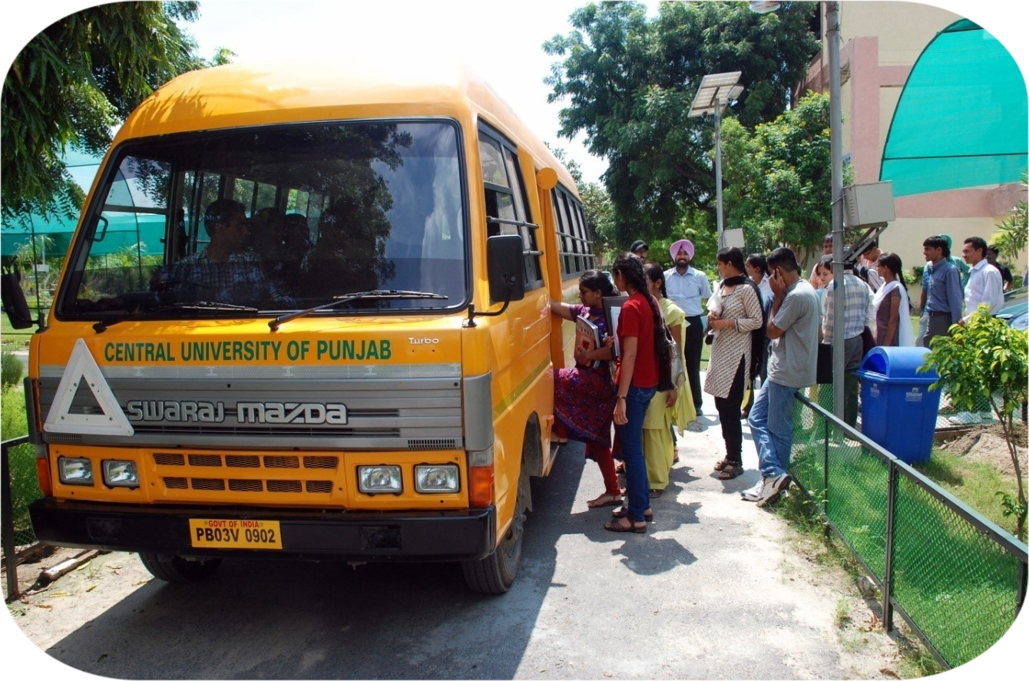

The university has purchased a 32 seater air-conditioned bus for convenience of the faculty and students. It shuttles between Bathinda city and the City Campus twice daily. Two more buses will be purchased in the new session.

xxv. ATM Facility

The university has on campus ATM’s of SBP and PNB for easy access.

xxvi. Auditorium

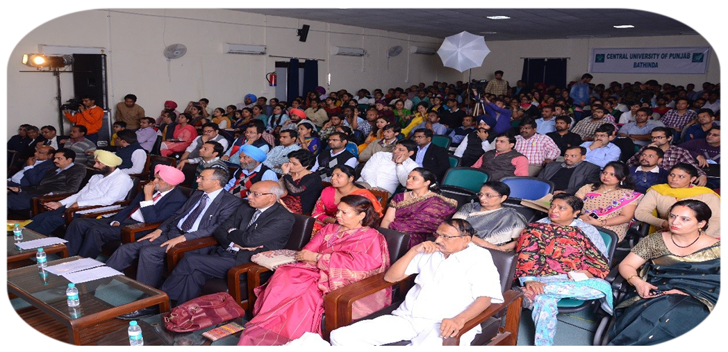

A modern auditorium is available for the academic and cultural activities of the university. The air-conditioned auditorium features a sitting capacity of around 250 and equipped with state-of-the-art remotely operated multimedia projectors, tablet PCs (Apple iPad) and 5.1 surround-sound theatre system.

xxvii. Museum

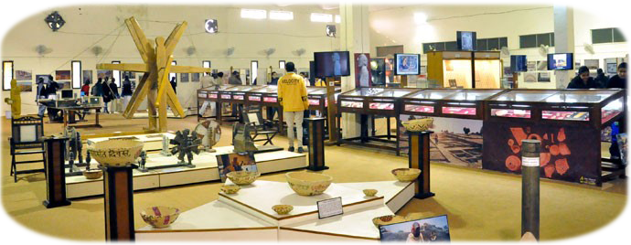

University museum houses vast collection of archaeological exhibits, including that of Harappan Civilization, excavated from Malwa region of Punjab. Exhibits also include a photo gallery on historical and cultural transformation of Bathinda City. The museum is being continuously expanded and more permanent galleries are scheduled to be opened for public in this year. Chief curator of the Museum is Dr. Vinay Kumar Rao, Associate Professor, COC Centre for South and Central Asian Studies.

xxviii. Sports

Besides beautiful walking trails and bikeways around the campus, CUPB has good sports facilities for the students and staff. Indoor badminton and table tennis courts are available round the clock to foster sporting skills. Outdoor badminton, volleyball and basketball courts are ready for use. Running track, a football ground and a cricket ground are getting ready.

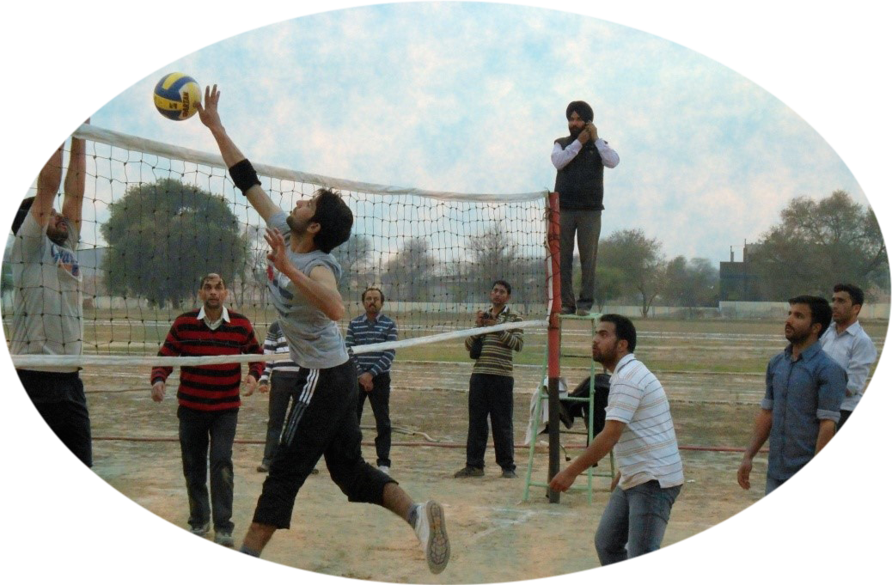

xxix. Fitness Centre

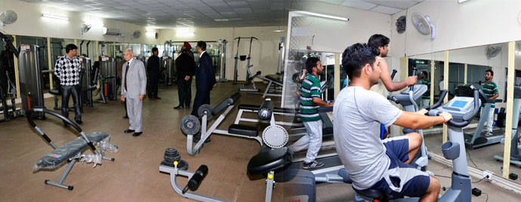

An air-conditioned fully functional physical fitness centre is operational in the University for ensuring a healthy mind in a healthy body. In order to gear up for extensive research work the students and the faculty work out in the air conditioned gymnasium in the university under the guidance of the sports expert. There are separate timings for males and females. The centre has all the requisite instruments and equipment required for exercising. Facilities in the centre include:

|  |  |
| --- | --- |
| * Aerobic studios with high-power treadmills * Decline bench * Upright stationary bike * Incline bench * Free-Weight training * Preacher curl bench * Cross trainer * Weight rack * Chest and shoulder presses | * Dumbbells 1 kg-20 kg * Leg press and extension * Rubber-coated weight plates * Cross pull down * Weighing machine * Smith machine * Twister * Olympic flat bench * Stretching equipment |

Important: Students who intend to use the fitness centre are required to contact [Dr. Gagandeep, Sports Officer](http://cup.ac.in/staff.asp#FF11)

xxx. Student Financial Assistance

**Earn While You Learn Scheme**

The university encourages the students to take up part time jobs at the university to make them independent under the “Earn While You Learn" scheme on campus to make the students:

i. Exploit the immense potential of students as a valuable human resource.

ii. Involve the students in management and development of the institution.

iii. Give students hands on experience and thereby prepare them for jobs in future.

iv. Encourage young students to learn about dignity of labour.

v. Prevent students from avoidable distractions and engage them in meaningful, positive activities.

vi. Enable meritorious and needy students to earn a reasonable amount every month to meet their expenses.

The students who are registered in CUPB for any programme and are not recipients of fellowship/financial aid from any other funding agency, either private or public can take the advantage of this scheme.

**Students’ financial assistance fund**

Students Financial Assistance Fund has been created with an objective that no deserving student, as far as possible, is denied opportunity of studying at the University merely due to her/his financial constraints. The deserving students with weak economic background will be eligible for grant subject to the below conditions. However, the amount of grant or loan will depend upon parents’ income and family size etc.:

The performance in the qualifying examination should be up to the mark. The attendance of the student at Central university of Punjab, Bathinda should be at least 75% and also academic performance at least “good standing”. She/he should have completed the previous semester successfully. There should be no disciplinary action or proceedings against the student.

The students can avail of the grant for pursuing studies, payment of tuition fee/ payment of registration fee, medical treatment: in case of serious illness demanding hospitalization, attending national international meets, conferences, seminars towards payment of registration fees, 2nd class Train or Bus travel with in India or in specific cases even travel abroad (partial assistance) and any other with the approval of competent authority.

**Education loan facility**

Central University of Punjab makes all efforts to ensure that the financial needs of its students are met. For the present it has tied up with four nationalized banks viz Punjab National Bank, Oriental bank of Commerce, Bank of India and State Bank of India for providing Education loan facility to students. All the Banks have stalls in the premises of the University for the Guidance of students and grant of education loan during counselling.

Xxx1. Placement Cell

The Placement Cell of the university has been established in the university with an aim of facilitating interactions between the industries, companies and students who are in the final year of their course. The purpose of the placement cell is to place students in credible organizations, and help them getting an appropriate job in sync with their intellectual aptitude.To provide excellent facilities for learning combined with a rewarding career is the motto of the institution. The students are provided with the best research facilities and the lab infrastructure for the execution of their innovative ideas. Helping them to execute it, the dedicated faculty of the institute helps them in comprehending the labyrinths of scientific world. The faculty of the institute have published an impressive number of research papers in several peer reviewed national and international journals in diverse areas of science, engineering and humanities, have a number of projects and grants from the leading funding agencies and have awards and honours to their merit.

The students are counselled throughout, during their stay in the university regarding their career options, which in turn prepare and equip the young aspirants to explore the best avenues of opportunities.

**Placement Coordination Cell**

* Prof. Dr. A. K. Jain, Dean (Placement Cell Coordinator)
* Dr. Anjana Munshi, Associate Professor, COC for Human Genetics
* Mrs. Shweta Arora, Deputy Registrar
* Mr. Rajender Kumar, Assistant Registrar

**Placement Cell - Sciences:**

* Prof. R.C. Sharma, School for Environment and Earth Sciences- Chairman
* Dr. Pankaj Bhardwaj, Assistant Professor, Centre for Biosciences
* Dr. Yogalakshmi K.N., Assistant Professor, Centre for EVST
* Dr. Sandeep Singh, Assistant Professor, Centre for GDMM
* Dr. Preeti Khetarpal, Assistant Professor, Centre for Human Genetics
* Dr. Achcche Lal Sharma, Assistant Professor, Centre for Physical and Mathematical Sciences

**Placement Cell - Engineering and Technology:**

* Prof. Dr. A.K. Jain, Dean - Chairman
* Er. Meenakshi, Assistant Professor, Centre for Computer Science and Technology
* Dr. Vinod Kumar, Assistant Professor, Centre for Chemical and Pharmaceutical Sciences

**Placement Cell - Humanities:**

* Dr. Zameerpal Kaur, Associate Professor, Centre for Comparative Literature- Chairperson
* Dr. Kiran K. Singh, Assistant Professor, Centre for South and Central Asian Studies
* Dr. Deepak Kumar, Assistant Professor, Centre for Environmental Law

Student Counselling Cell

**Objectives**

* To counsel and guide CUPB students on various issues and help them to manage academic and personal demands of a university life effectively
* To help students of all beliefs and identities who may react to certain events with feelings that include anger, hurt, confusion, fear, helplessness, loneliness, and hopelessness
* To counsel the students requesting a withdrawal from a specific academic programme for non-academic reasons.
* To provide prompt counselling for mental health emergencies arising on account of highly charged events at the campus.

The Student Counselling Cell shall provide comprehensive preventive and clinical services to students enrolled for various academic programmes in the universlty. The goal of the cell would be to enhance the psychological wellbeing of CUPB students so they can take full advantage of the educational opportunities at the University. Some of the presentations that the Counselling Center will offer include academic success skill, conflict resolution, dealing with difficult situations, stress management techniques and time management. All student contacts and information obtained in the course of counselling will be confidential.

**Members**

* 1. Prof. S.K. Bawa, Professor Chairperson
* 2. Dr. Sushil Kumari Gupta, OSD Administration
* 3. Dr. Anjana Munshi, Associate Professor
* 4. Dr. Tarun Arora, Associate Professor
* 5. Ms. Shweta Arora, Deputy Registrar Convener

xxxii. Grievance Redressal Cell

In order to attend to the students' complaints, a grievance redressal cell has been set up in the university. It offers immediate and effective redressal to the problems reported by the students and work towards providing a safe and secure atmosphere for the holistic growth of the students.

|  |  |  |  |
| --- | --- | --- | --- |
| **Type of sub-committee** | | **Members** | |
| Appeals Committee (School wise for students; one for employees) | * + Dean of the School/Head of Department or Section   + Coordinators of Centres concerned/ immediate Senior | |
| Review Committee | * + Dean Academic Affairs   + Dean Students Welfare/Registrar | |
| Mercy Appeals Committee | * + Vice Chancellor | |

xxxiii. Anti-Ragging Cell

The university has a zero tolerance policy towards ragging-related matters. All issues in this regard will be dealt with utmost urgency and stringent action will be taken against those who are involved. A copy of UGC regulations on curbing the menace of ragging have been distributed to all students upon admission and have procured undertakings and affidavits from the students as well as parents in this regard. Unabridged version of the UGC regulations in this regard can be accessible athttp://bit.ly/UGC-Ragging.

In compliance with the Directions of University Grants Commission, the competent authority has constituted Anti-Ragging Committee, Anti Ragging Squad/Cell and Nodal Officer at Central University of Punjab as per the details given below.

**Anti-Ragging Committee at Central University of Punjab**

* Prof. A.K. Dhawan, Professor (DSW)
* Dr. Sanjeev Kumar, Associate Professor
* Dr. Sandeep Kaur Bhatia, Assistant Professor
* Mrs. Shweta Arora, Deputy Registrar

**Anti-Ragging Squad at Central University of Punjab**

* Dr. Zameerpal Kaur, Associate Professor
* Dr. Kiran Kumari Singh, Assistant Professor
* Dr. Sanjeev Kumar, Associate Professor
* Dr. Pankaj Bhardwaj, Assistant Professor
* Dr. Puneeta Pandey, Assistant Professor
* Dr. M.S. Dhanya, Assistant Professor
* Dr Hans Raj Arora, Associate Professor
* Dr. Gagandeep, Sports Officer

**Nodal Officer** Prof. A.K. Dhawan, Professor (DSW)

xxxiv. Anti-Discrimination Cell

The university community comprises of heterogenous population from different parts of country, different religious/caste affiliations, linguistic heterogeneity and persons with various financial backgrounds. Discriminations based on caste/sex/appearance/state of domicile etc. will be dealt with extreme seriousness.

The university puts very best efforts to ensure that the minority community faces no discriminating incidents in the campus.

**Members of Anti-Discrimination Cell**

* Prof. A. K. Dhawan, Dean, School of Health Sciences – Anti Discrimination Officer
* Dr. Dhanya M.S., Assistant Professor - Member
* Dr. Sukhwinder Kaur, Assistant Professor - Member
* Dr. Vinod Arya, Assistant Professor - Member
* Ms. Shweta Arora, Deputy Registrar-Member

xxxv. Competitive Examination Cell

To prepare the students to face different competitive examinations and help them acquire the requisite knowledge to excel in their studies, the university has a competitive examination cell which conducts coaching classes for exams like UGC/CSIR-NET, ICMR, DBT, GATE, GPAT, Civil services examination, etc. Classes for these competitive examinations are held in the evening, so that the regular class schedule of the university is not disturbed.

Coaching is provided in General Knowledge, Information and Communication Technology (ICT), Reasoning (Including Mathematical), Current Affairs, Data interpretation, Research Aptitude, People and environment, Higher Education System: Governance, Polity And Administration for UGC NET paper- I examinations. For CSIR Net examination coaching is provided in Life Sciences, Environmental Sciences, Chemical sciences and other subjects. Subject specific classes are conducted on the basis of the demand raised by the students. These classes are also in the form of remedial classes. The faculty members also put efforts to provide guidance for the slow learners. A team of committed teachers and specialists of proven merit provide a professional edge to the Cell. Over the years, the CEC has catered to the need of students with fair degree of success. This has greatly helped to improve the performance of all the students in various examinations. CEC, in the long run, will start coaching for civil services examinations.

**Objectives:**

* To provide intensive subject specific coaching for UGC/CSIR-NET, ICMR, DBT, GATE, GPAT etc. and Civil services examination ( in future)
* To build positive state of mind and self-confidence among the students;
* To encourage SC/ST/OBC and women candidates to appear in competitive examinations.

**Coordinators of Competitive Examination Cell**

* Dr. Kiran Kumari Singh, Assistant Professor, Centre for Geography and Geology.
* Dr. Puneet Pathak, Assistant Professor, Centre for Law.

xxxvi. Student Discipline

All students are expected to abide by the rules and regulations of the Central University of Punjab. Breach of any rule or any other misconduct shall render the student liable for disciplinary action, including expulsion from the university.

Attendance requirements: All students must attend their classes regularly. The minimum requirement of attendance is 75% of the scheduled lectures.

Use of Mobile phones: Students possessing mobile phones must keep them switched off when in class/labs. Carrying a mobile phone even in switched off mode during examinations is strictly prohibited and shall amount to use of unfair means.

Ragging of any student in any form inside or outside the campus is punishable offence as per guidelines of Honorable Supreme Court of India with minimum punishment of expulsion from CUPB.

Misbehaviour: Students found misbehaving with other students or staff member will face disciplinary action.

Infrastructure Damage: Students must take care of their campus. Any student found damaging the university infrastructure will be fined to recover the losses.

Ignorance of the rules and regulations of the institute will not be entertained as an excuse.

xxxvii. Student Code of Conduct

The university recognizes and values the diversity of students and their expectations. The university is committed to treating students in a fair and transparent manner. The code of conduct is formulated to provide a clear statement of the university’s expectations of students in respect of academic matters and personal behaviour.

* The student must submit their assignments, lab files, seminar reports etc given by the teachers in time.
* No student must abstain from classes without prior permission.
* Students are expected to speak politely and use decent language when communicating with university officials, staff members and other students.
* Students must maintain decorum in the university bus
* It is the students’ responsibility to update any changes in their parents/ guardians and their own address and contact number within a week.
* Wearing a helmet for two wheeler drivers is a statutory requirement
* Use all university resources including information technology in a lawful and ethical manner for academic purposes only.
* The students are expected to bear a good moral character.

xxxviii. Feedback System

Teaching and learning is a continuous process in which teacher and student develops a bond. Teachers keep getting new students year after year and with the passage of time gain rich experience. In order to improve her/his competence in teaching and/ or research she/he needs the feedback from the students. The students can provide their feedback at the end of every semester for each course by hiding their identity. The feedback form is to be filled online, the data of which is kept confidential and is used only for improvement purposes

xxxix. Alumni Association

Central University of Punjab Alumni Association (CUPAA)

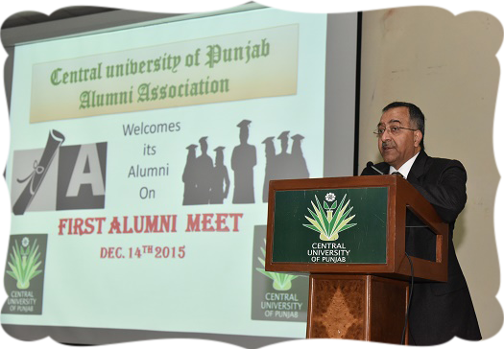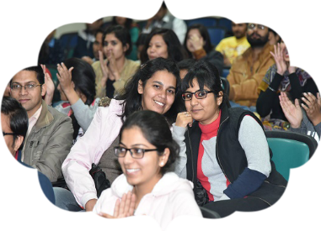

Teaching and learning is a continuous process in which teacher and student develops a bond. Teachers keep getting new students year after year and with the passage of time gain rich experience. In order to improve her/his competence in teaching and/ or research she/he needs the feedback from the students. The students can provide their feedback at the end of every semester for each course by hiding their identity. The feedback form is to be filled online, the data of which is kept confidential and is used only for improvement purposes

CUPAA aspires to foster an increased interaction amongst the alumni. A series of activities will be organized once the association becomes active. A glimpse of what we as facilitators intend to do is:

* To set up a link with the alumni of all the centres and enroll them as members
* To encourage the alumni to take an active and continued interest in the activities and progress of the University
* To honour those distinguished alumni members, who bring laurels to themselves as well as the university  in their respective domains
* To arrange get- togethers of the alumni on a regular basis

xxxx. Important Contacts CUPB

|  |  |
| --- | --- |
|  | 0164-2430586  0164-2864111 Telefax |
| Registrar | 2864-106 |
| Controller of Examinations | 2864-115 |
| Dean Academic Affairs | 2864-105 |
| Dean Students Welfare | 2864-115 |
| Dean School of Basic and Applied Sciences | 2864-105 |
| Dean School of Environment and Earth Sciences | 2864-159 |
| Dean School of Emerging Life Sciences | 2864-130 |
| Dean School of Health Sciences | 2864-130 |
| Dean School of Languages, Literature and Culture | 2864-210 |
| Dean School of Engineering and Technology | 2864-145 |
| Dean School of Global Relations | 2864-210 |
| Dean School of Legal Studies and Governance | 2864-105 |
| Dean School of Education | 2864-210 |
| University Health Centre | 2864-157 |
| Main Gate Security | 2864-124 |
| Boys’ Hostel | 2864-208 |
| Girl’‟ Hostel | 2864-207 |
| Railway Inquiry | 139/ 164-2255901 |

About Bathinda

Bathinda is a place with its roots in the ancient Indus Valley Civilisation. The sites excavated nearby Mansa belong to pre-Harappan, Harappan and late Harappan periods. Its earlier name was Bikramgarh as mentioned in History of Patiala, by Khalifa Muhammad Hassan. However, during 10th -11th centuries, the city name was Tabarhind. The Bhattis ruled it for a long period, and Rao Bhatti established the town of Bathinda and Bhatner which were fortified and linked through a tunnel. The fort, Qila Mubarak, is thus more than one thousand years old.

In the Slave Dynasty (1206-1526) Bathinda remained under the rule of Sultans of Delhi. The first famous woman ruler, Razia Sultana, who ruled India from 1236 to 1240, was imprisoned in Bathinda fort in 1240. In 1706 the Tenth Guru of Sikhs, Guru Gobind Singh visited the town and stayed in the fort for some time before going to Talwandi Sabo where he dictated Adi Granth. A gurudwara is located inside the fort in his memory.

After being declared a district in 1948, Bathinda made rapid strides in agriculture and industry, so that once arid lands are now yielding bumper crops including grapes. The monuments of its modern history include Guru Nanak Dev Thermal Plant, other thermal plant at Lehra Mohabbat, National Fertilizers Limited and Guru Gobind Singh Refinery.

Bathinda has emerged not only as one of the biggest food grain markets but also

an important centre of education, having schools and colleges including a medical college and an engineering college. With the establishment of Central University of Punjab another sparkling pearl has been added to this string with the aim to educate and train manpower in this economically backward region for the overall development of the state and the country.

Climate



On left: Average temperature: Average daily (24h) temperature per month. The temperature normals are measured in the period 1961–1990. On Right: Average precipitation. The graph shows average amount of days (24h) with precipitation during a month. When precipitation has surpassed 1mm per day (24h) it is defined as a day with precipitation. The mean period is 1961–1990. Data credits: Norwegian Meteorological Institute.

List of Gazetted Holidays

